**Population Dynamics Review Sheet**

**SC.912.L.17.5** *Analyze how population size is determined by births, deaths, immigration, emigration, and limiting factors (biotic and abiotic) that determine carrying capacity.*

A population consists of all the individuals of a species that live together in one place at one time. Every population tends to grow because individuals tend to have multiple offspring over their lifetime. A population grows when more individuals are born than die in a given period. But eventually, limited resources in an environment limit the growth of a population.

When population size is plotted against time on a graph, the population growth curve resembles a *J*-shaped curve and is called an exponential growth curve. An exponential growth curve is a curve in which the rate of population growth stays the same, and as a result, the population size increases steadily.

However, populations do not usually grow unchecked. Their growth is limited by predators, disease, and the availability of resources. Eventually, growth slows, and the population may stabilize. The population size that an environment can sustain is called the carrying capacity.

As a population grows, limited resources (that is, resources in short supply) eventually become depleted. When this happens, the growth of the population slows. The population model can be adjusted to account for the effect of limited resources, such as food and water. These resources are called density-dependent factors because the rate at which they become depleted depends upon the population density of the population that uses them. The population model that takes into account the declining resources available to populations is called the logistic model of population growth, after the mathematical form of the equation. The logistic model is a population model in which exponential growth is limited by a density-dependent factor. Unlike the simple model, the logistic model assumes that birth and death rates vary with population size. When a population is below carrying capacity, the growth rate is rapid.

However, as the population approaches the carrying capacity, death rates begin to rise and birthrates begin to decline. Competition for food, shelter, mates, and limited resources tends to increase as a population approaches its carrying capacity. The accumulation of wastes also increases. As a result, the rate of growth slows. The population eventually stops growing when the death rate equals the birthrate.

1. What kind of growth curve is shown by the graph to the right?
2. What is the carrying capacity for rabbits?
3. During what month were rabbits in exponential growth?

In the space below, draw and label the two different types of population growth curves. Write a brief description next to each graph.



1. What type of population growth curve shows a carrying capacity?
2. What type of population growth is at risk for a population crash? Explain why
3. How does the availability of resources affect population growth?
4. How are birth rate and death rate related to the rate of population growth in an ecosystem?
5. Isle Royale National Park on a remote island was established in 1940, and designated a wilderness area in 1976. The only mode of transportation available is by boat or seaplane. Moose first arrived at Isle Royale around 1900. The moose population tends to increase in years with mild winters, early spring green-up, abundant winter forage, low wolf numbers and low levels of tick infestation. Wolves first arrived at the island on an ice bridge from Canada in 1940. Disease has also influenced the wolf population. Between 1980 and 1982, the wolf population declined from 50 to 14, due to canine 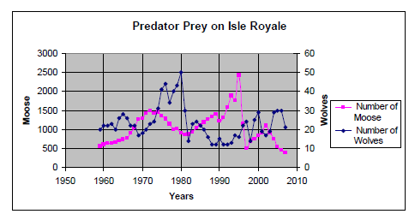parvovirus.

1. What would happen to the wolf population if the moose population decreases?
2. What would happen to the moose population if the wolves were removed from Isle Royale?
3. Describe the pattern between the wolf (predator) populations in relation to the moose (prey) population.
4. Are predator-prey relationships density-dependent or density-independent limiting factors? Explain.
5. Researchers have found that a local squirrel population fluctuates from year to year, increasing one year and decreasing the next. Which of the following factors would cause the squirrel population to grow?
6. A the birth rate is equal to the death rate
7. B emigration is greater than immigration
8. C the death rate is higher than the birth rate
9. D the birth rate is greater than the death rate
10. All populations fluctuate in size. Which of the following is a non-environmental factor that might cause a population to be reduced in size?
11. decreased predation
12. increased competition
13. emergence of disease resistance
14. increased availability of a food source
15. Your class has been observing the population growth of a species of Paramecium, a single-celled organism, for 18 days. Your data are shown in the graph below. Food was occasionally added to the test tube in which the paramecia were grown.

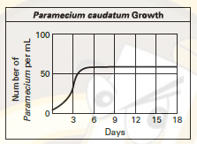

Look at the graph above. What is the carrying capacity of the test-tube environment as long as food is added?

1. A about 10 paramecia
2. B about 50 paramecia
3. C about 75 paramecia
4. D about 100 paramecia
5. An animal population decreases from 800 individuals to 600 individuals. Which of the following could explain this change in population size?
6. The population size of the animal’s predator increased.
7. The emigration rate of the animals from the population decreased.
8. The number of breeding pairs in the animal’s population increased.
9. The number of species competing with the animal for food decreased Based