**Classification and Cladograms**

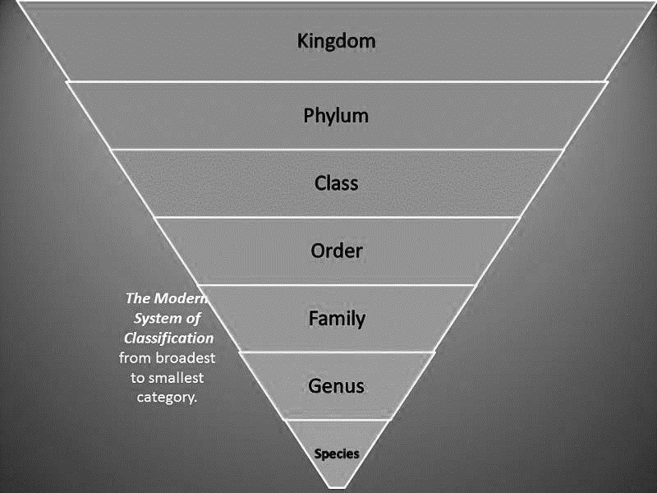**SC.912.L.15.4 Describe how and why organisms are hierarchically classified and based on evolutionary relationships.**

In the 18th century, Carl Linnaeus published a system for classifying living things, which has been developed into the modern classification system. People have always given names to things that they see, including plants and animals, but Linnaeus was the first scientist to develop a hierarchal naming structure that conveyed information both about what the species was (its name) and also its closest relatives. The ability of the Linnean system to convey complex relationships to scientists throughout the world is why it has been so widely adopted.

Classification of many species, old and new, continues to be disputed as scientists find new information or interpret facts in new ways. One of the new reasons why species are being re-evaluated is because of DNA analysis. Basic genetic analysis information can change our ideas of how closely two species are related and so their classification can change, but how does the whole system work?

**Kingdom:** When Linnaeus first described his system, he named only two kingdoms – animals and plants. Today, scientists think there are at least five kingdoms – animals, plants, fungi, protists and monera (bacteria).

**Phylum:** Below the kingdom is the phylum. Phyla have also been developed and reorganized since the original work by Linnaeus – as scientists discover more species, more categories and subcategories are put in place.

**Class**:Each phylum is then divided into classes.

**Order:** The class will then be subdivided into an order.

**Family:** From the order, the organism will be classified into a family.

**Genus and species**: Finally, the classification will come to the genus (plural genera) and species. These are the names that are most commonly used to describe an organism. One outstanding feature of the Linnean classification system is that two names are generally sufficient to differentiate from one organism to the next. Here's a clear summary of the Linnean system of **binomial nomenclature**, the scientific way to name living things with a two part generic (genus) and specific (species) name.

1. What is the largest group in the classification system?
2. If your name was a scientific name what part would be the genus?
3. 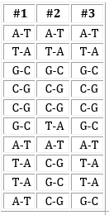Today, scientists do look at organisms physical features, but mostly they classify organisms based on evolutionary classification (grouping organisms based on their evolutionary history) Scientists determine an organisms evolutionary history by looking at gene sequence similarities in its DNA and RNA as well as looking at its physical characteristics. To the right is a gene sequence of 3 similar organisms. Which two are more closely related?

**Cladograms** are branching diagrams where each branch represents an evolutionary lineage. We put the names of specific taxa at the end of each branch and we put the names of groups to which those taxa belong at the intersection of branches (nodes). Check out the example below that uses mammals.

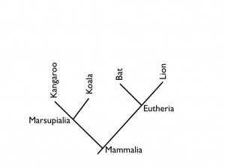The diagram doesn’t really have axes, but implied in the x direction is some sort of evolutionary distance from each other and implied in the y direction is relative time (the first branch at the bottom happened long ago the latter branches higher up happened more recently). This diagram tells you that all the animals listed are mammals (see the group name Mammalia at the bottommost node). The koala and kangaroo are more closely related to one another than to anything else on the diagram. Their branches intersect each other before they intersect any other lineage. This indicates that they diverged from each other more recently than they diverged from any of the other animals on the diagram. Furthermore, they both belong to the group Marsupialia.

1. Are the bat and lion or the bat more closely related than the bat and koala? Why?

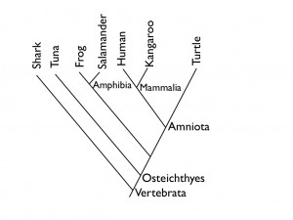Here we can see some interesting relationships. Notice you (assuming you are a human) are more closely related to a turtle than you are to a frog (you and the turtle are both amniotes, part of the group Amniota). Now, as you work your way down the diagram things start to really get interesting. The tuna is more closely related to humans than it is to sharks. Surprising right? I know what you’re thinking “Is that really true?” Sure it is. See the distance between the ‘Vertebrata’ node and the ‘Osteichtyes’ node? That distance is shared evolution between humans and tunas that sharks don’t share (they’ve already branched off). Put another way, this means that tunas and humans have a few extra million years of evolution in common that tunas and sharks don’t.

1. Which are more closely related, the Human and Salamander or the Human and Kangaroo?
2. 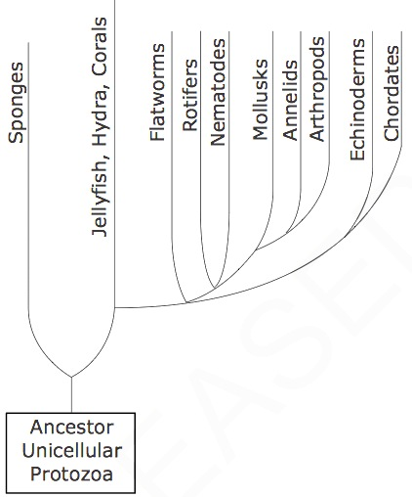The diagram below shows a cladogram for various organisms. Which two groups of organisms have the most genetic differences?
3. rotifers and nematodes
4. mollusks and annelids
5. mollusks and arthropods
6. echinoderms and chordates
7. 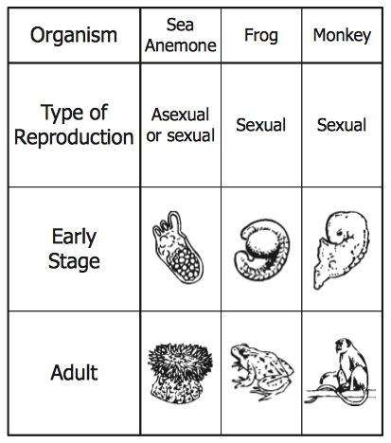 The information in the table supports which conclusion?

A. Frogs are more closely related to monkeys than to sea anemones.

B. Frogs, monkeys, and sea anemones are classified into different kingdoms.

C. Sea anemones are more complex than frogs or monkeys.

D. Sea anemones and monkeys are adapted to similar environments.