**SC.912.L.15.1 Explain how the scientific theory of evolution is supported by the fossil record, comparative anatomy, comparative embryology, biogeography, molecular biology, and observed evolutionary change.**

**FOSSIL RECORD:** includes a variety of different extinct organisms that are related to one another and to living species. The sizes, shapes, and varieties of organisms preserved in fossils changed over time

* Layers of rock contain **fossils**
* new layers cover older ones
* **creates a record over time**
* show a series of **organisms that** have lived on Earth.

1. Fossil A is found at a depth of 17 meters, Fossil B is found at a depth of 12 meters, Fossil C is found at a depth of 4 meters. What can be inferred about the age of the fossils?

**Comparative anatomy:** – (also known as homologous body structures) – the form and function of bones differs from animal to animal but are all constructed from the same bone structure (see diagram below). This is evidence that the animals evolved from common ancestors.

* 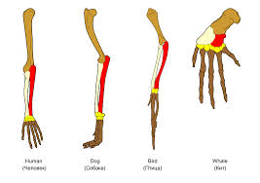Evidence for evolution comes from comparing the body parts of different species
* Homologous Structures are similar in structure but appear in different organisms and have different functions.
* 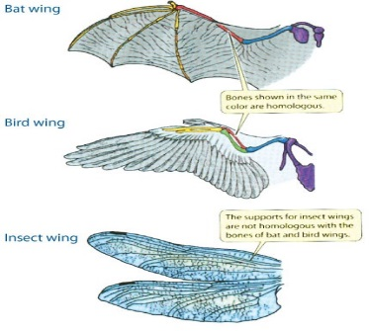What does the prefix “homo-” mean?
* An analogy compares two things that are different, but have the same function.
* You may have heard the mitochondria compared to a JEA power plant. They are different, but both produce energy.
* **Comparative embryology**: the early stages of development for many animals with backbones are very similar.
* Embryos are organisms in their earliest stage of development.
* 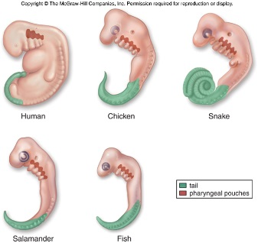It is difficult to distinguish different vertebrates from each other by just looking at the embryos.
* For example, fish, birds, reptiles, and mammals all have gill slits as embryos. The gill slits become gills in adult fish. In mammals, the gill slits develop into structures of ears and throats.

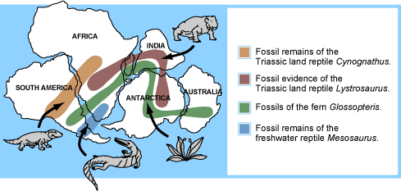**Biogeography:** organisms from different areas are similar, but distinctly different based on where they are found. For example, the Galapagos islands have finches that all have different beaks from island to island. The environment on each particular island produced finches with adaptations to that environment. The geographic isolation of each environment is what makes each species of bird distinct from one another.

* Indicates a common ancestor
* The distribution of fossils across the continents is one line of evidence pointing to the existence of Pangaea
* Pangaea: Supercontinent that existed 300 million years ago.

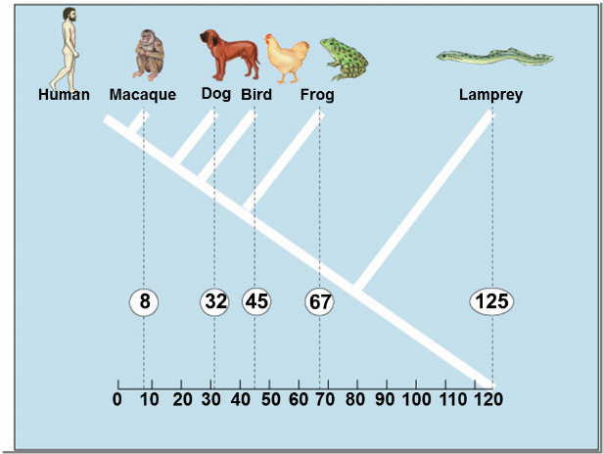**Molecular biology:** all organisms share the same basic molecular structure (DNA)

* Comparing DNA and protein structure
* Everyone uses the same genetic code

Why is Evolution just a Theory?

* A scientific theory is inference based on careful examination of facts.
* A theory is not observable.

We cannot observe evolution in our lifetime, but we can look at pieces of the puzzle and infer what we assume is happening.

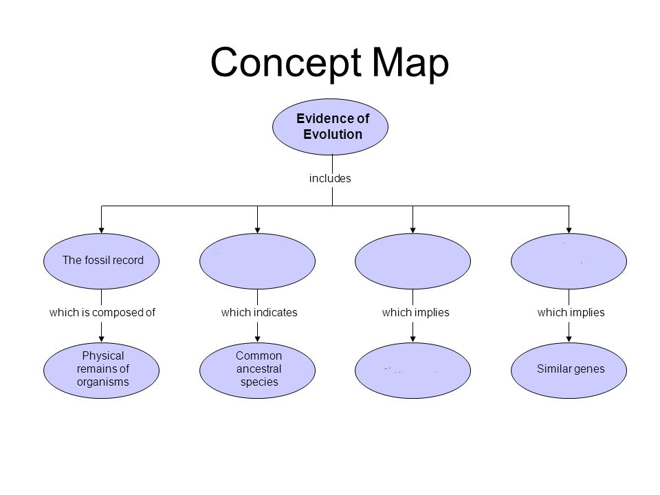Complete the graphic organizer below using the information above.

1. In 2008, the remains of a Saber Tooth Tiger was found in the coastal areas of the United Kingdom. Scientists were able to capture intact DNA sequences and found it was similar to the African lion. Which of the following conclusions can the scientists formulate about the Saber Tooth tiger and the African lion?
   1. African lions and Saber Tooth tigers have a mutual ancestor.
   2. African lions outcompeted Saber Tooth tigers causing their extinction.
   3. African ions and Saber Tooth tigers should be classified as the same species.
   4. African lions and Saber Tooth tigers have the same number of chromosomes.
2. The scientific theory of evolution is supported by different types of evidence. The diagrams below show the skeletons of two different animal species. How does comparing the skeletons of these animals provide support for the scientific theory of evolution?
   1. It provides information about the organisms' habitats.
   2. It shows possible common ancestry between organisms.
   3. It provides information to determine the organisms' ages.
   4. It shows possible chromosomal similarities between organisms.
3. The chart below details the partial DNA sequences of four different animals.

|  |  |
| --- | --- |
| **Comparative DNA Sequences of 4 Different Animals** | |
| A | ATT TAC ATG CTC CTA ATC GCG ATT |
| B | ATT TAC CTG CTC GTA ATC GCG ATT |
| C | ATG TAG ATC GAA CGG ATA CAG AAT |
| D | ATG TAG AAC GAA CAG ATA CAC AAT |

According to an evolutionary biologist, which one of these animals would be **most** closely related?

* 1. A and C
  2. B. C and D
  3. C. B and D
  4. A and B

1. The diagram illustrates an embryonic stage of two organisms.

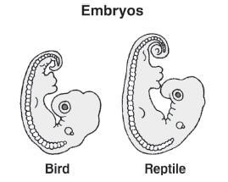

Which of the following can be determined by observing the embryos shown in the diagram?

* 1. The organisms share a common ancestry.
  2. The organisms belong to the same genus.
  3. The organisms are native to the same geographic areas.
  4. The organisms will grow into anatomically similar adults.