THE CONNECTIONS TO STATISTICS
AND PROBABILTY
DOMAIN
15%
S.ID.1
Represent data with plots on the real number line (dot plots, histograms, and box plots).

S.ID.2
Use statistics appropriate to the shape of the data distribution to compare center (median, mean) and spread (interquartile range, mean absolute deviation, standard deviation) of two or more different data sets.

S.ID.3
Interpret differences in shape, center, and spread in the context of the data sets, accounting for possible effects of extreme data points (outliers).

S.ID.5
Summarize categorical data for two categories in two-way frequency tables. Interpret relative frequencies in the context of the data (including joint, marginal, and conditional relative frequencies). Recognize possible associations and trends in the data.

S.ID.6
Represent data on two quantitative variables on a scatter plot, and describe how the variables are related.

S.ID.6a
Decide which type of function is most appropriate by observing graphed data, charted data, or by analysis of context to generate a viable (rough) function of best fit. Use this function to solve problems in context. Emphasize linear, quadratic and exponential models.

S.ID.6c
Using given or collected bivariate data, fit a linear function for a scatter plot that suggests a linear association.

S.ID.7
Interpret the slope (rate of change) and the intercept (constant term) of a linear model in the context of the data.

S.ID.9
Distinguish between correlation and causation.

S.ID.8
Compute (using technology) and interpret the correlation coefficient “r” of a linear fit. (For instance, by looking at a scatterplot, students should be able to tell if the correlation coefficient is positive or negative and give a reasonable estimate of the “r” value.) After calculating the line of best fit using technology, students should be able to describe how strong the goodness of fit of the regression is, using “r”.

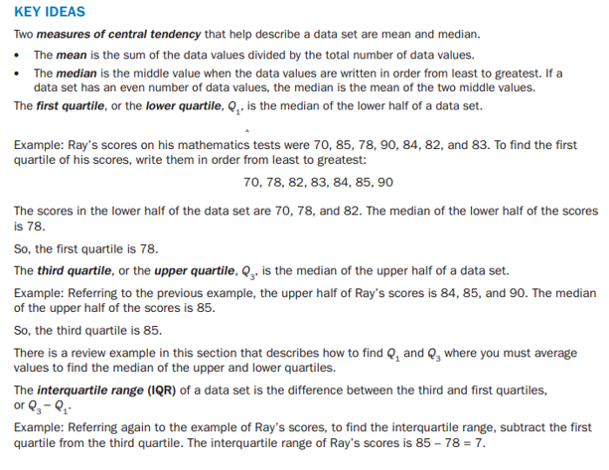
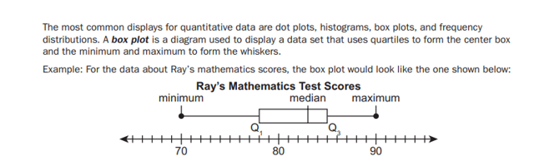
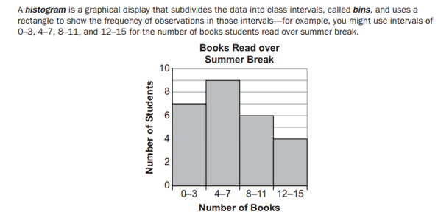
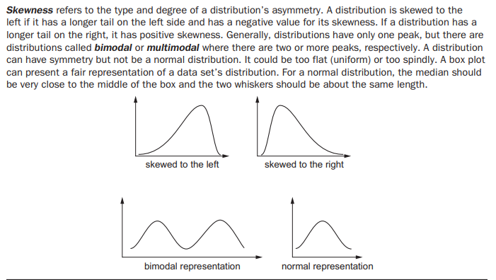
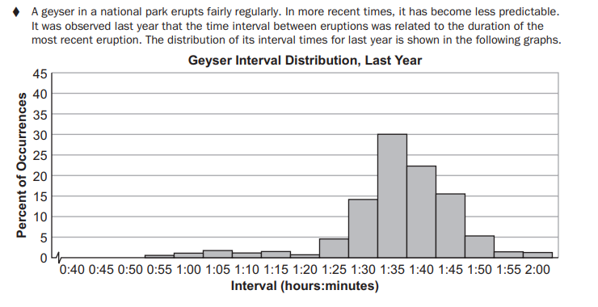
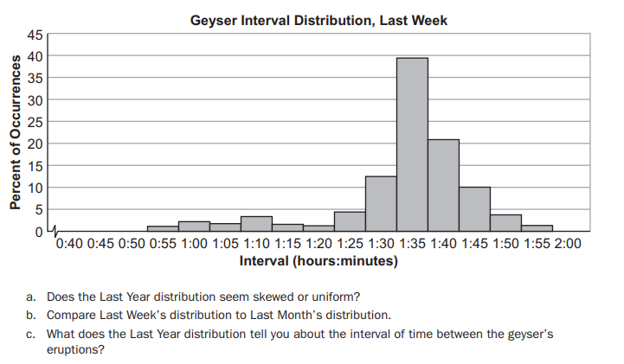
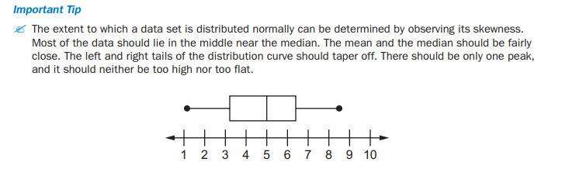
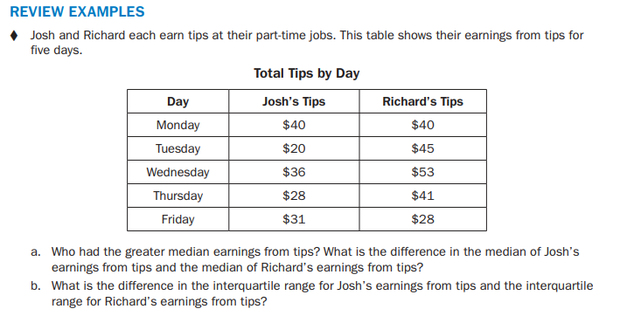
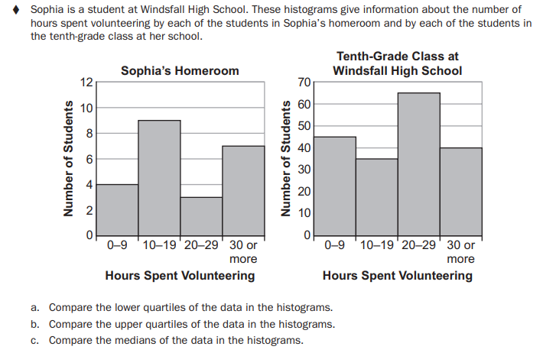
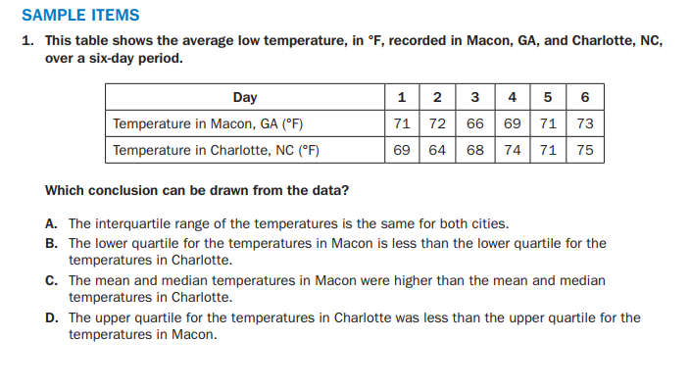
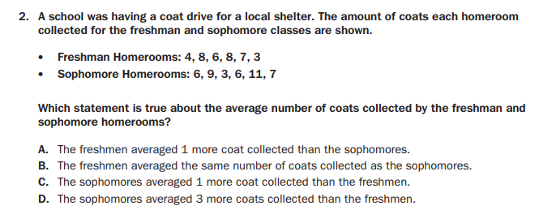

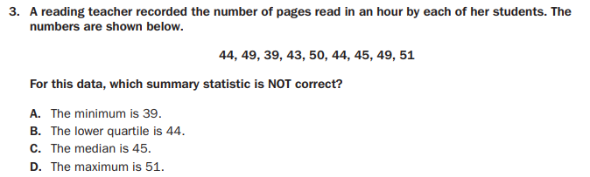

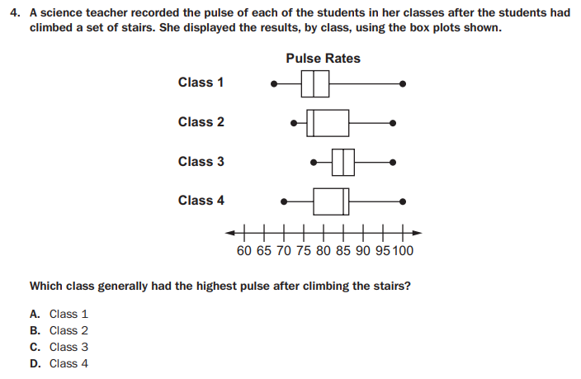
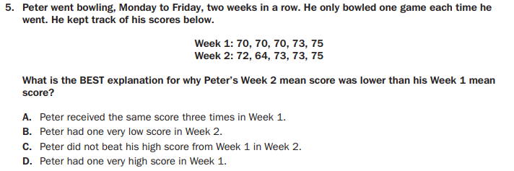
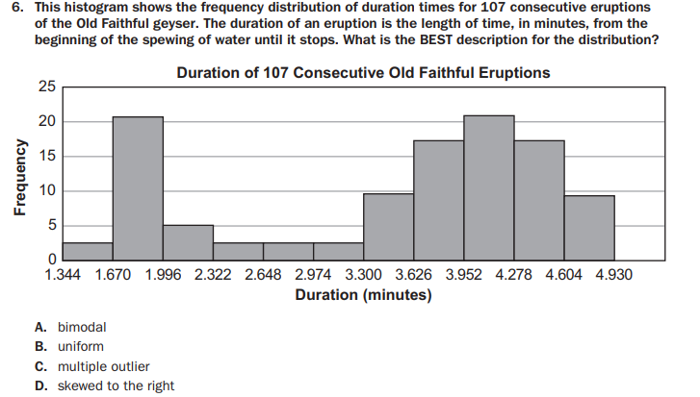

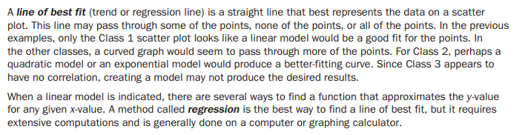
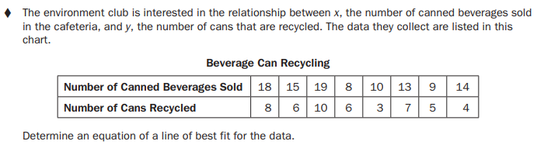
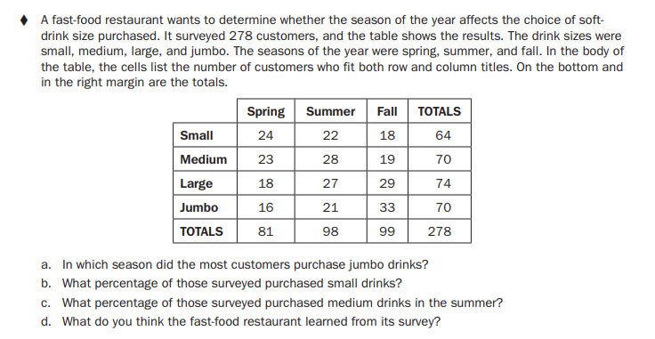
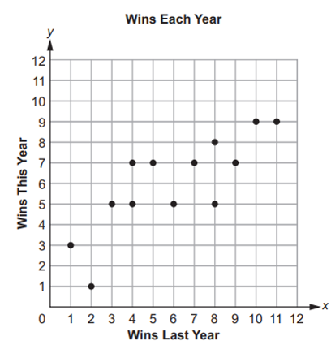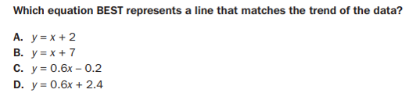
A Correlation Coefficient is the measure of the strength of the linear relationship.
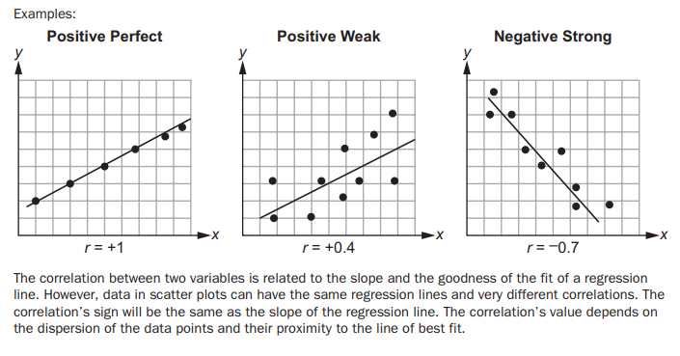
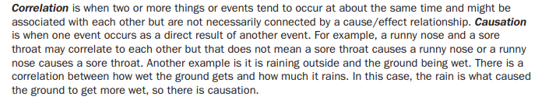
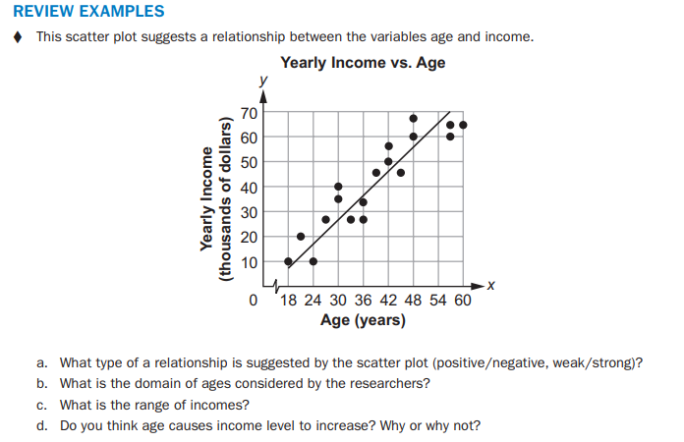

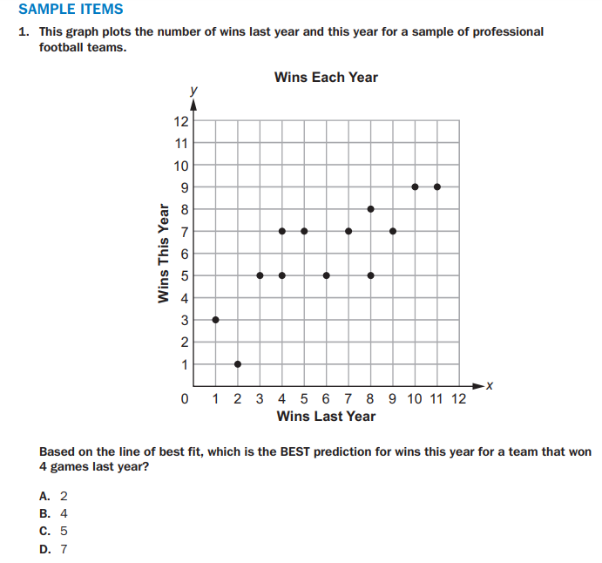
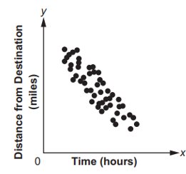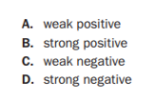
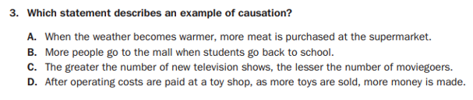
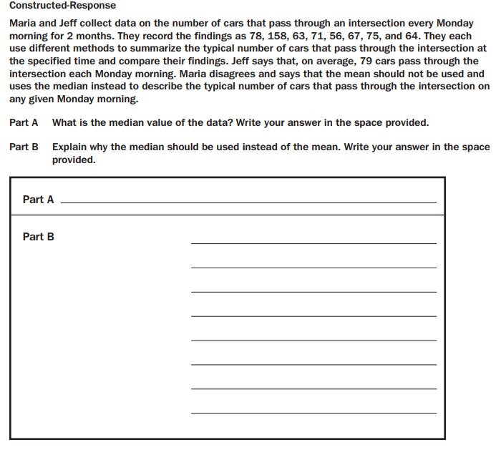

THE EXPRESSIONS
DOMAIN
20%
N.RN.2
Rewrite expressions involving radicals and rational exponents using the properties of exponents. (i.e., simplify and/or use the operations of addition, subtraction, and multiplication, with radicals within expressions limited to square roots). Use properties of rational and irrational numbers.

N.RN.3
Explain why the sum or product of rational numbers is rational; why the sum of a rational number and an irrational number is irrational; and why the product of a nonzero rational number and an irrational number is irrational.
A.SSE.1
Interpret expressions that represent a quantity in terms of its context.

A.SSE.1a
Interpret parts of an expression, such as terms, factors, and coefficients, in context.

A.SSE.1b
Given situations which utilize formulas or expressions with multiple terms and/or factors, interpret the meaning (in context) of individual terms or factors.

A.SSE.2
Use the structure of an expression to rewrite it in different equivalent forms. For example, see
$x^{4}-y^{4}$ as ${\left(x^{2}\right)}^{2}-{\left(y^{2}\right)}^{2}$, thus recognizing it as a difference of squares that can be factored as $\left(x^{2}-y^{2}\right)\left(x^{2}+y^{2}\right)$

A.SSE.3
Choose and produce an equivalent form of an expression to reveal and explain properties of the quantity represented by the expression.

A.SSE.3a
Factor any quadratic expression to reveal the zeros of the function defined by the expression.

A.SSE.3b
Complete the square in a quadratic expression to reveal the maximum or minimum value of the function defined by the expression.

A.APR.1
Add, subtract, and multiply polynomials; understand that polynomials form a system analogous to the integers in that they are closed under these operations.

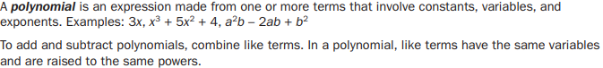
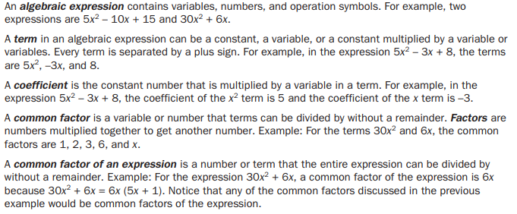
 | 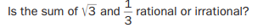
 | 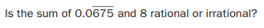
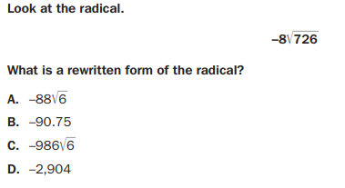 | 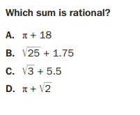
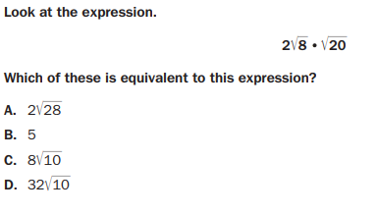 | 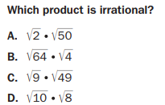
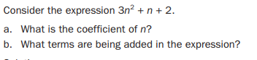 | 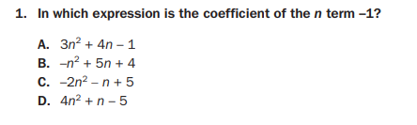
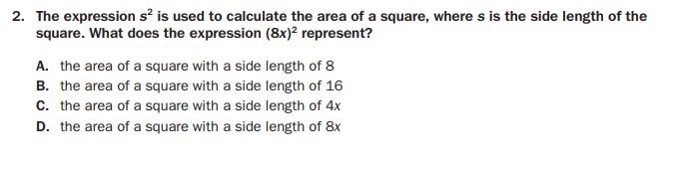 | 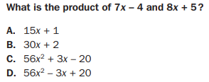
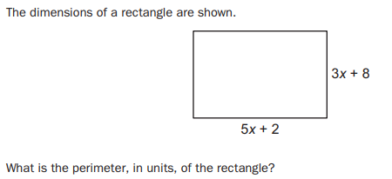 | 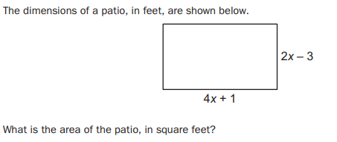
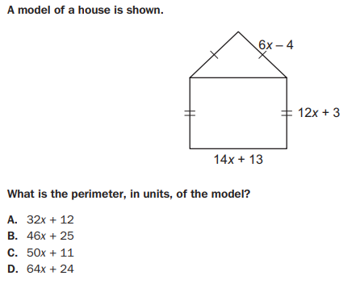 | 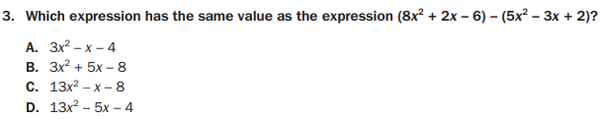
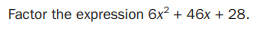 | 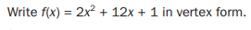
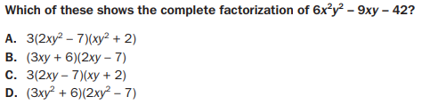 | 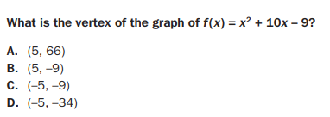
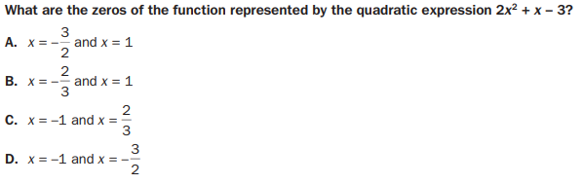
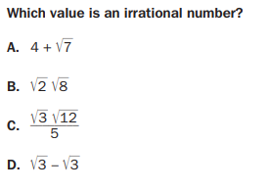 | 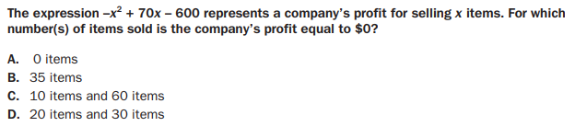
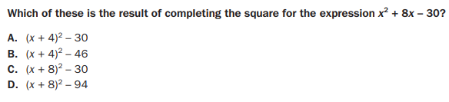 | 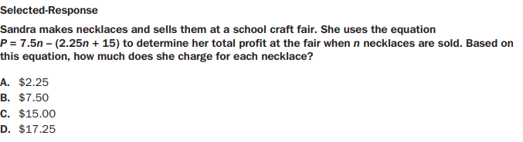
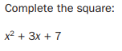 | 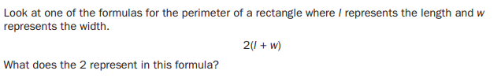
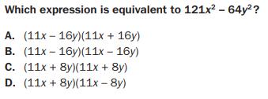 | 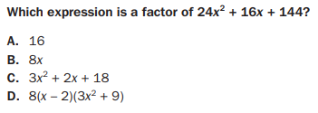
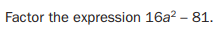 | 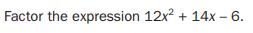
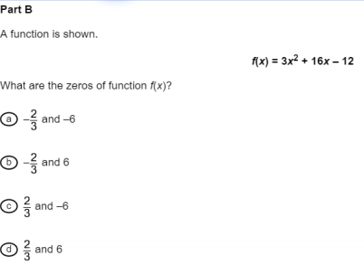 | 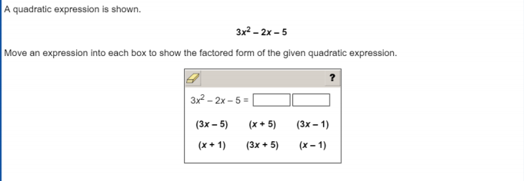
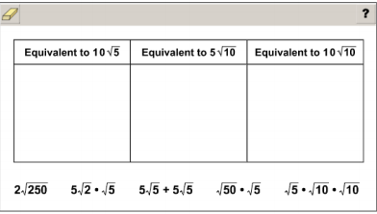
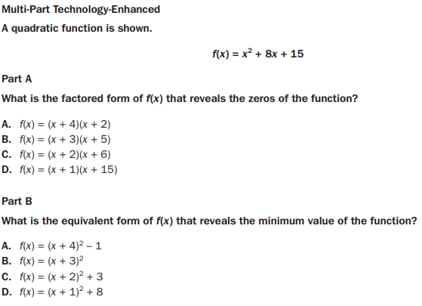
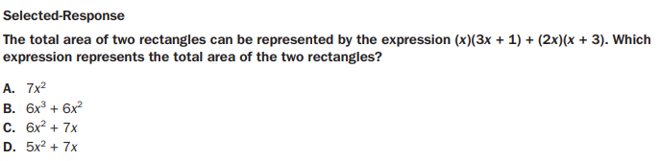

THE EQUATIONS
DOMAIN
30%
N.Q.1 Use units of measure (linear, area, capacity, rates, and time) as a way to understand problems: a. Identify, use, and record appropriate units of measure within context, within data displays, and on graphs; b. Convert units and rates using dimensional analysis (English-to-English and Metric-to-Metric without conversion factor provided and between English and Metric with conversion factor); c. Use units within multi-step problems and formulas; interpret units of input and resulting units of output.
N.Q.2 Define appropriate quantities for the purpose of descriptive modeling. Given a situation, context, or problem, students will determine, identify, and use appropriate quantities for representing the situation.
N.Q.3 Choose a level of accuracy appropriate to limitations on measurement when reporting quantities. For example, money situations are generally reported to the nearest cent (hundredth). Also, an answers’ precision is limited to the precision of the data given.
A.CED.1 Create equations and inequalities in one variable and use them to solve problems. Include equations arising from linear, quadratic, simple rational, and exponential functions (integer inputs only).
A.CED.2 Create linear, quadratic, and exponential equations in two or more variables to represent relationships between quantities; graph equations on coordinate axes with labels and scales. (The phrase “in two or more variables” refers to formulas like the compound interest formula, in which
A = P(1 + r/n)^{nt} has multiple variables.)
A.CED.3 Represent constraints by equations or inequalities, and by systems of equations and/or inequalities, and interpret data points as possible (i.e. a solution) or not possible (i.e. a non-solution) under the established constraints.
A.CED.4 Rearrange formulas to highlight a quantity of interest using the same reasoning as in solving equations. Examples: Rearrange Ohm’s law V = IR to highlight resistance R; Rearrange area of a circle formula
$A=πr^{2}$ to highlight the radius r.
A.REI.1 Using algebraic properties and the properties of real numbers, justify the steps of a simple, one-solution equation. Students should justify their own steps, or if given two or more steps of an equation, explain the progression from one step to the next using properties.
A.REI.3 Solve linear equations and inequalities in one variable including equations with coefficients represented by letters. For example, given ax + 3 = 7, solve for x.
A.REI.4a Solve quadratic equations in one variable. Use the method of completing the square to transform any quadratic equation in x into an equation of the form ${\left(x-p\right)}^{2}=q$ that has the same solutions.
A.REI.4b Solve quadratic equations by inspection (e.g., for $x^{2}=49$), taking square roots, factoring, completing the square, and the quadratic formula, as appropriate to the initial form of the equation (limit to real number solutions).
A.REI.5 Show and explain why the elimination method works to solve a system of two-variable equations.
A.REI.6 Solve systems of linear equations exactly and approximately (e.g., with graphs), focusing on pairs of linear equations in two variables.
A.REI.10 Understand that the graph of an equation in two variables is the set of all its solutions plotted in the coordinate plane.
A.REI.11 Using graphs, tables, or successive approximations, show that the solution to the equation f(x) = g(x) is the x-value where the y-values of f(x) and g(x) are the same.
A.REI.12 Graph the solution set to a linear inequality in two variables. Build a function that models a relationship between two quantities.

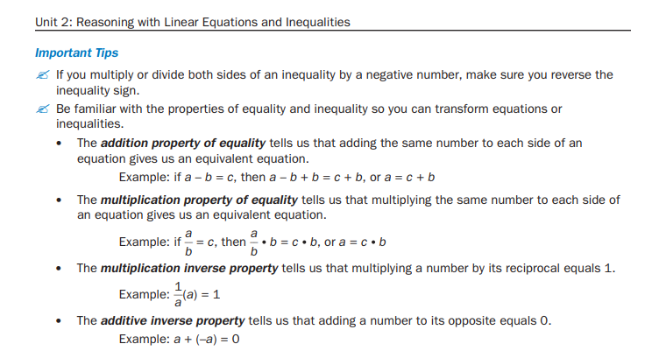
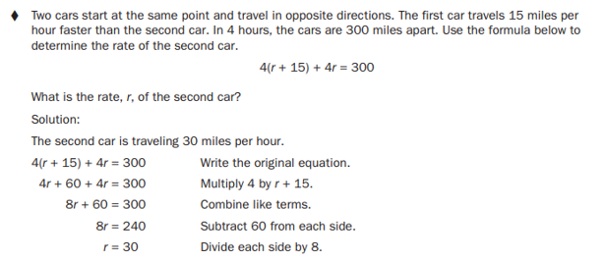

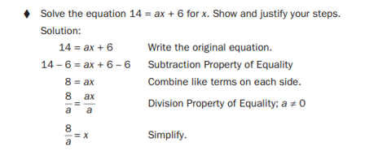
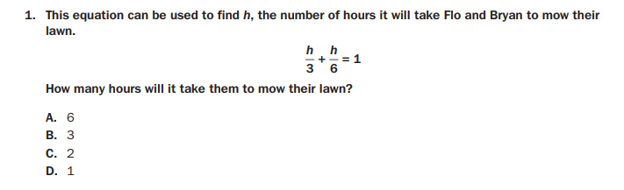
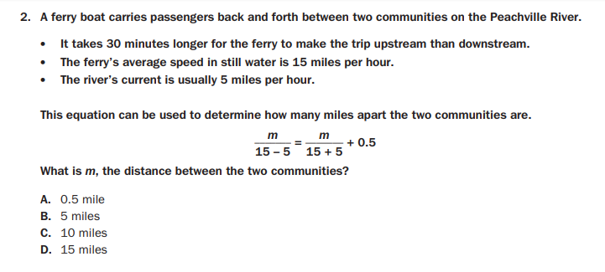
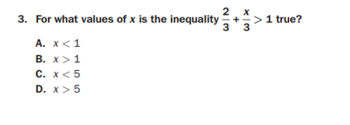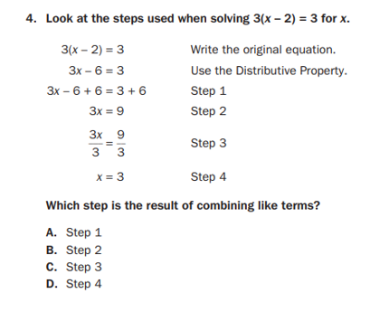
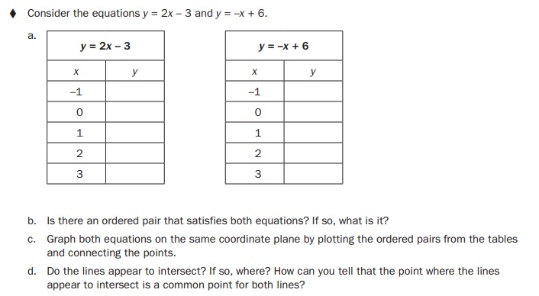

- The two lines are graphed on this coordinate plane
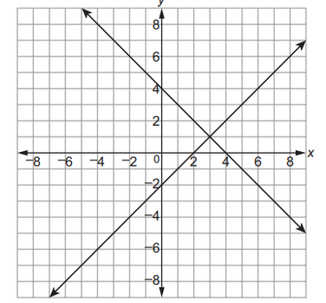

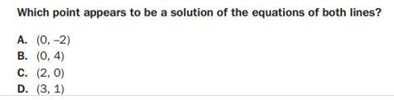

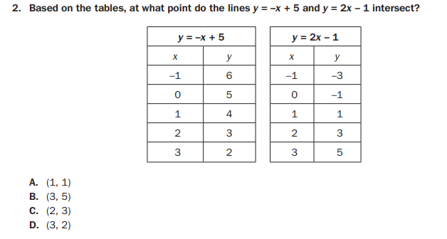

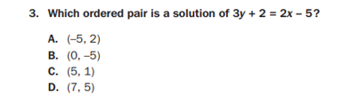

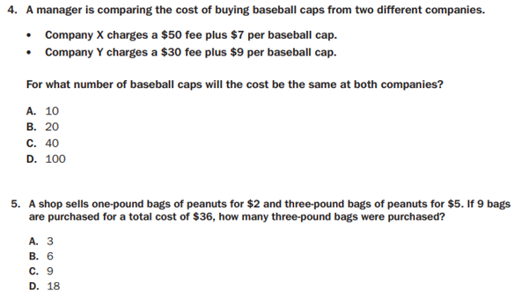
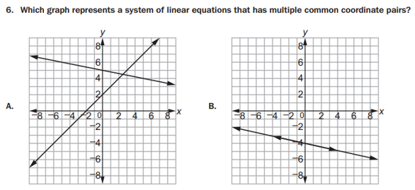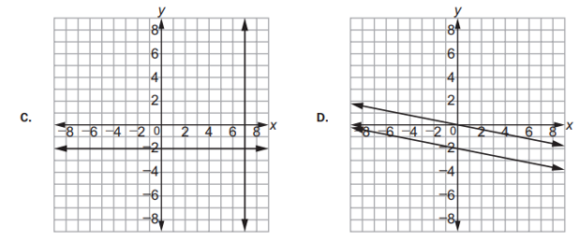
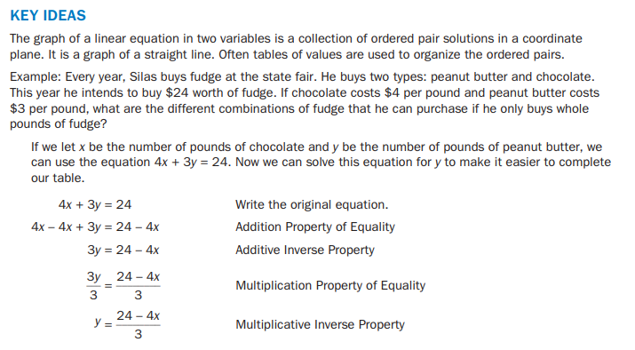

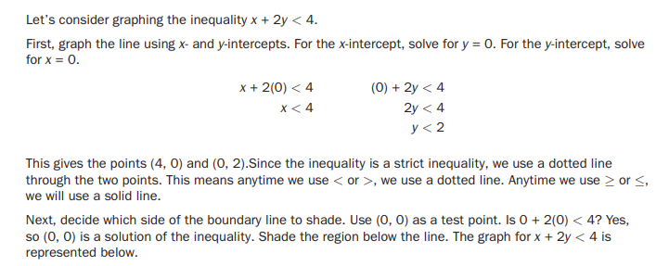

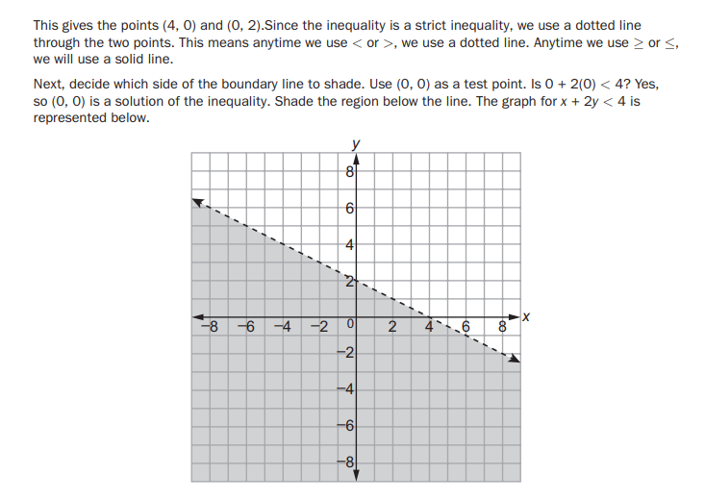

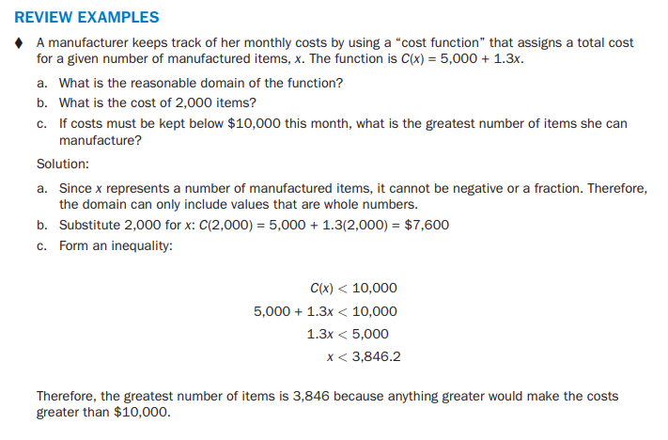
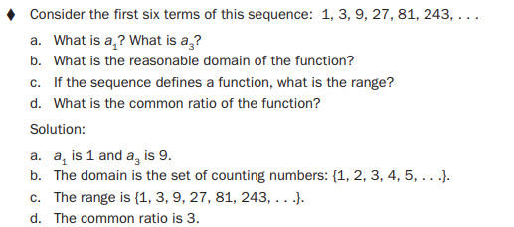
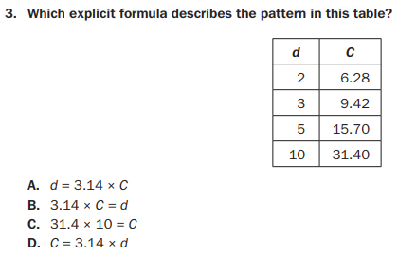

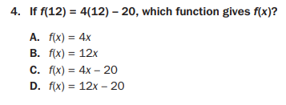
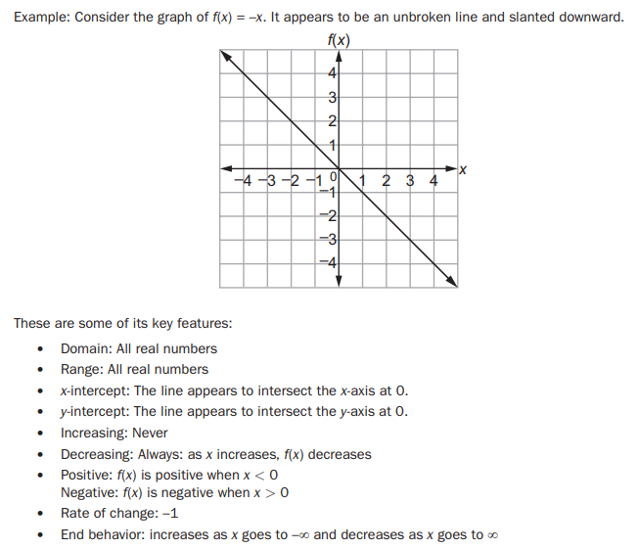
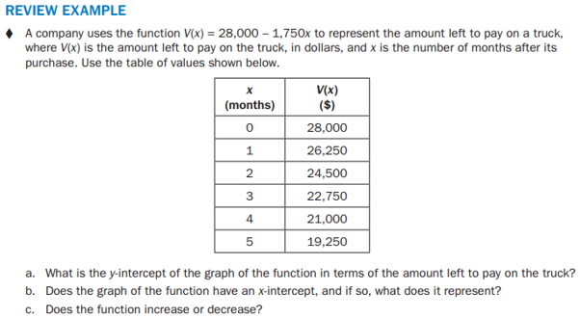
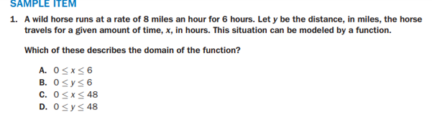
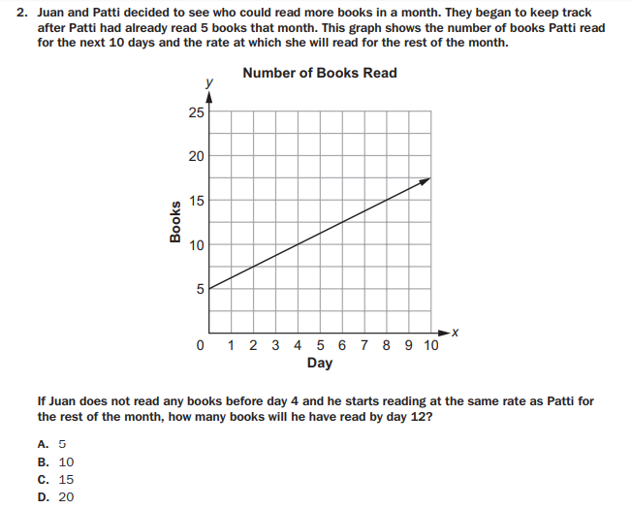
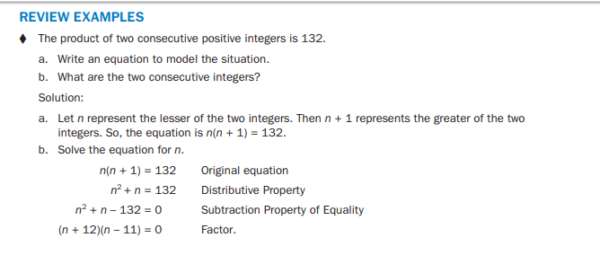

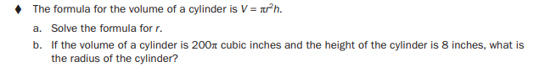

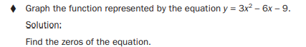

THE FUNCTIONS DOMAIN 35%

F.IF.1 Understand that a function from one set (the input, called the domain) to another set (the output, called the range) assigns to each element of the domain exactly one element of the range, i.e. each input value maps to exactly one output value. If f is a function, x is the input (an element of the domain), and f(x) is the output (an element of the range). Graphically, the graph is y = f(x).
F.IF.2 Use function notation, evaluate functions for inputs in their domains, and interpret statements that use function notation in terms of a context.
F.IF.3 Recognize that sequences are functions, sometimes defined recursively, whose domain is a subset of the integers. (Generally, the scope of high school math defines this subset as the set of natural numbers 1,2,3,4...) By graphing or calculating terms, students should be able to show how the recursive sequence a1=7, an=an-1 +2; the sequence
sn = 2(n-1) + 7; and the function f(x) = 2x + 5 (when x is a natural number) all define the same sequence.
F.IF.4 Using tables, graphs, and verbal descriptions, interpret the key characteristics of a function which models the relationship between two quantities. Sketch a graph showing key features including: intercepts; interval where the function is increasing, decreasing, positive, or negative; relative maximums and minimums; symmetries; end behavior; and periodicity.
F.IF.5 Relate the domain of a function to its graph and, where applicable, to the quantitative relationship it describes. For example, if the function h(n) gives the number of person-hours it takes to assemble n engines in a factory, then the positive integers would be an appropriate domain for the function.
F.IF.6 Calculate and interpret the average rate of change of a function (presented symbolically or as a table) over a specified interval. Estimate the rate of change from a graph.
F.IF.7aGraph functions expressed algebraically and show key features of the graph both by hand and by using technology.
Graph linear and quadratic functions and show intercepts, maxima, and minima (as determined by the function or by context).
F.IF.7e Graph functions expressed algebraically and show key features of the graph both by hand and by using technology.
Graph exponential and logarithmic functions, showing intercepts and end behavior, and trigonometric functions, showing period, midline, and amplitude.
F.IF.8aUse the process of factoring and completing the square in a quadratic function to show zeros, extreme values, and symmetry of the graph, and interpret these in terms of a context. For example, compare and contrast quadratic functions in standard, vertex, and intercept forms.
F.IF.9 Compare properties of two functions each represented in a different way (algebraically, graphically, numerically in tables, or by verbal descriptions). For example, given a graph of one function and an algebraic expression for another, say which has the larger maximum.
F.BF.1aDetermine an explicit expression and the recursive process (steps for calculation) from context. For example, if Jimmy starts out with $15 and earns $2 a day, the explicit expression “2x+15” can be described recursively (either in writing or verbally) as “to find out how much money Jimmy will have tomorrow, you add $2 to his total today.”
$$J_{n}=J_{n-1}+2J_{0}=15$$
F.BF.2 Write arithmetic and geometric sequences recursively and explicitly, use them to model situations, and translate between the two forms. Connect arithmetic sequences to linear functions and geometric sequences to exponential functions. Build new functions from existing functions
F.BF.3 Identify the effect on the graph of replacing f(x) by f(x) + k, k f(x), f(kx), and
f(x + k) for specific values of k (both positive and negative); find the value of k given the graphs. Experiment with cases and illustrate an explanation of the effects on the graph using technology. Include recognizing even and odd functions from their graphs and algebraic expressions for them.
F.LE.1a Distinguish between situations that can be modeled with linear functions and with exponential functions.
Show that linear functions grow by equal differences over equal intervals and that exponential functions grow by equal factors over equal intervals. (This can be shown by algebraic proof, with a table showing differences, or by calculating average rates of change over equal intervals).
F.LE.1b Recognize situations in which one quantity changes at a constant rate per unit interval relative to another.
F.LE.1c Recognize situations in which a quantity grows or decays by a constant percent rate per unit interval relative to another.
F.LE.2 Construct linear and exponential functions, including arithmetic and geometric sequences, given a graph, a description of a relationship, or two input-output pairs (include reading these from a table).
F.LE.3 Observe using graphs and tables that a quantity increasing exponentially eventually exceeds a quantity increasing linearly, quadratically, or (more generally) as a polynomial function.
F.LE.5 Interpret the parameters in a linear (f(x) = mx + b) and exponential (f(x) = $ad^{x}$) function in terms of context. (In the functions above, “m” and “b” are the parameters of the linear function, and “a” and “d” are the parameters of the exponential function.) In context, students should describe what these parameters mean in terms of change and starting value.

FUNCTONS STANDARDS F.IF. 1 – F.IF.9
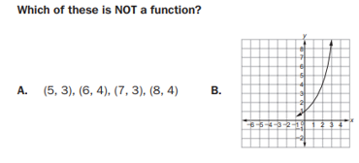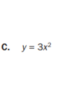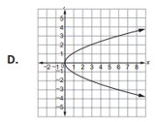
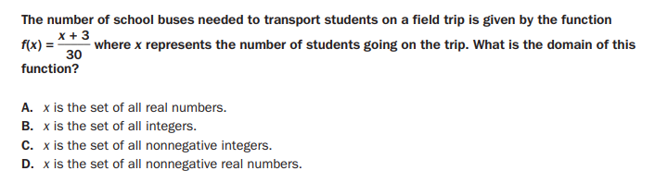
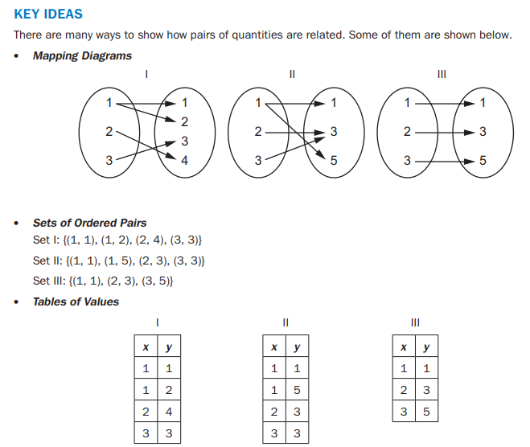
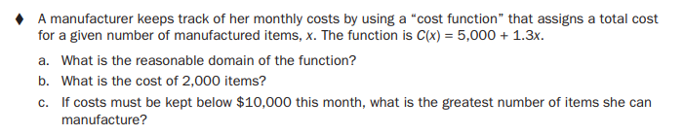
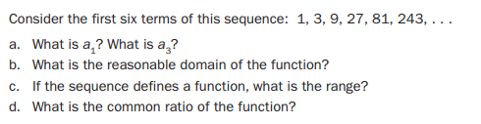
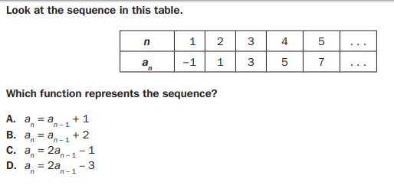 |  | 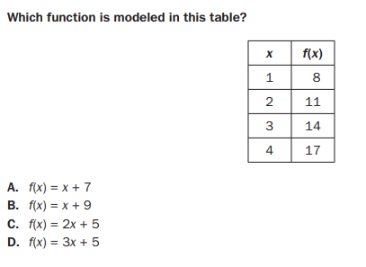
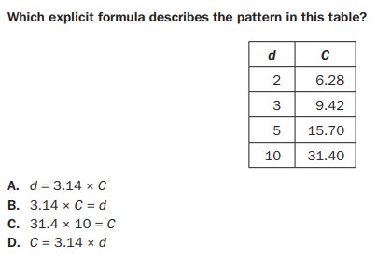 | 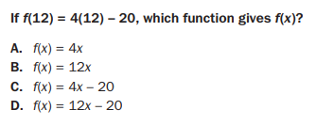
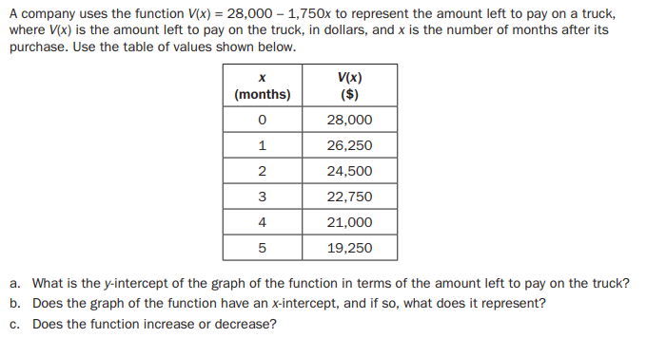

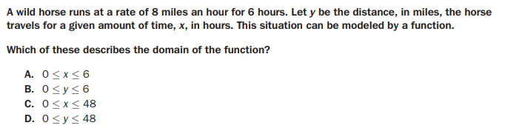
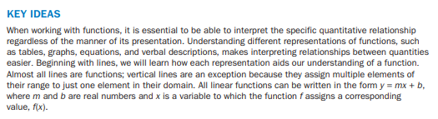

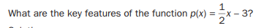

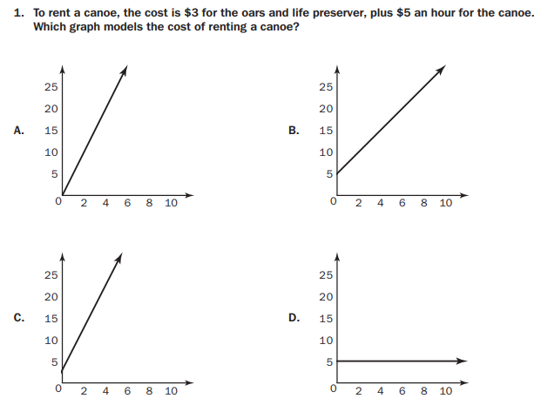
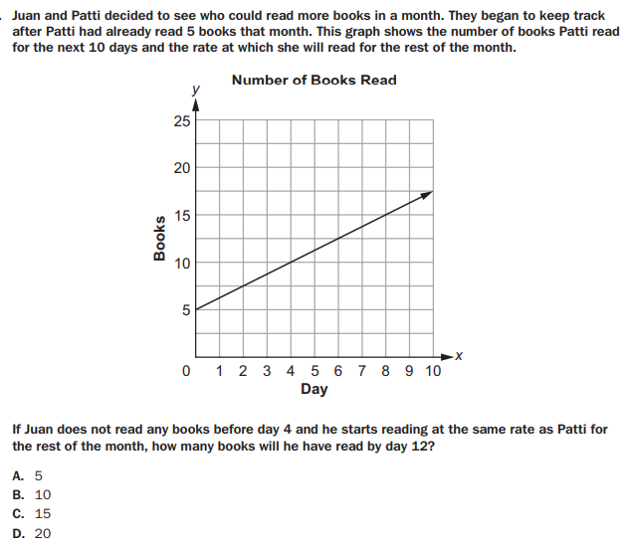

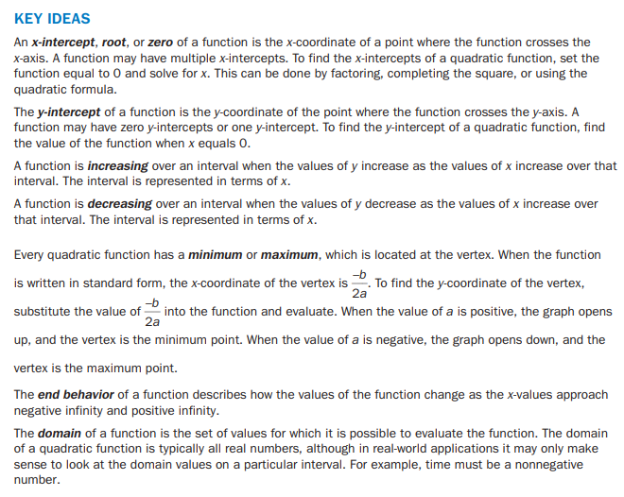
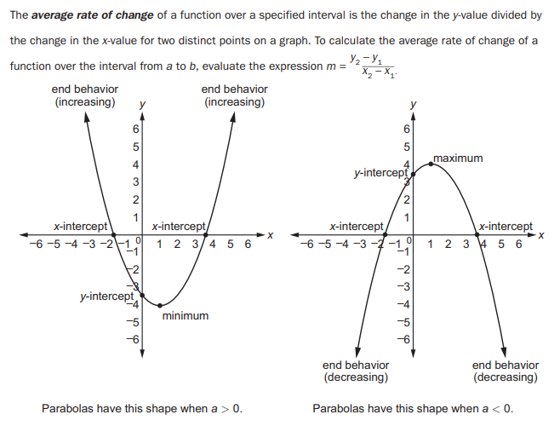

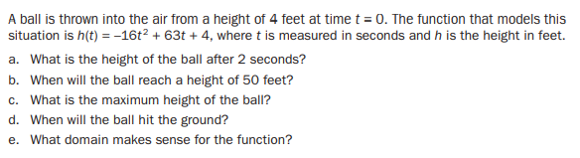
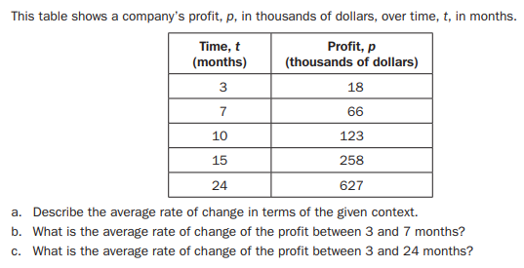
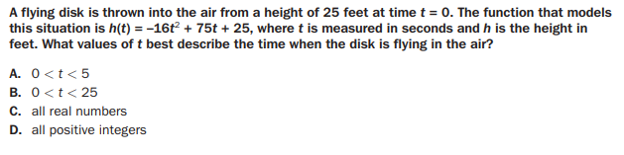

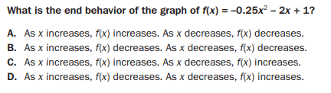\
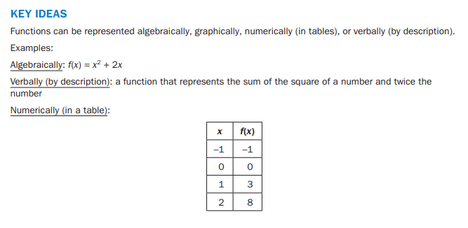
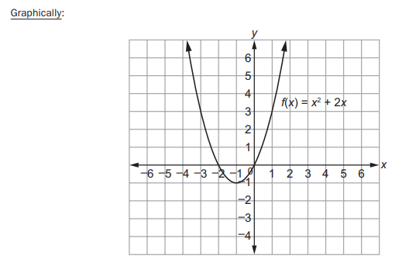
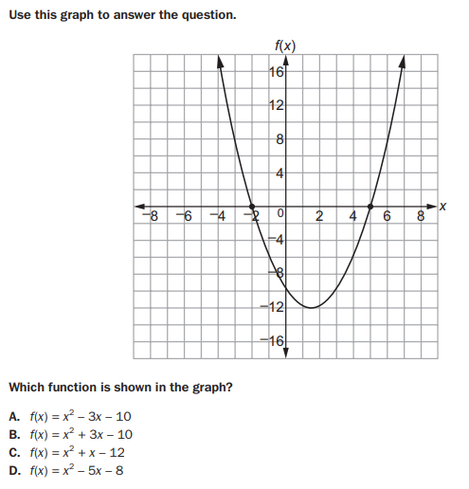
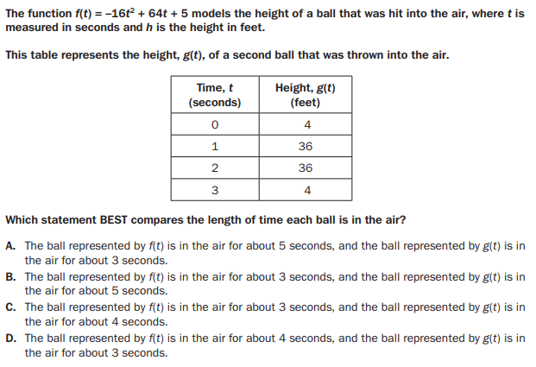
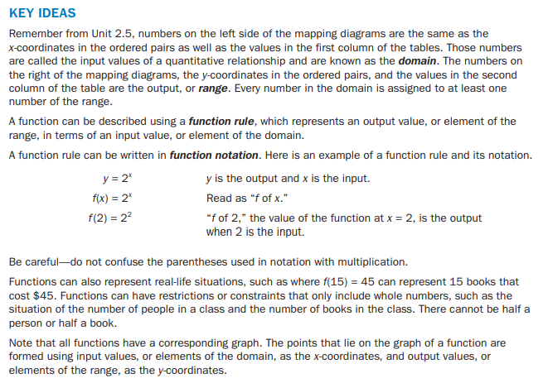
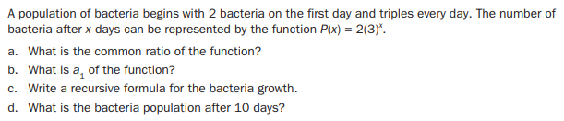
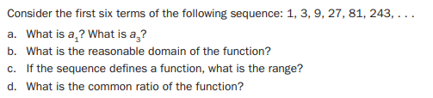
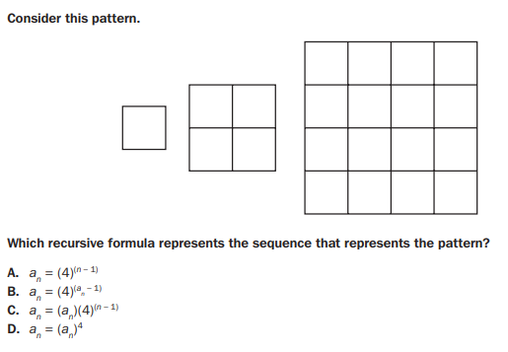 | 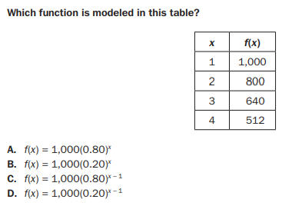
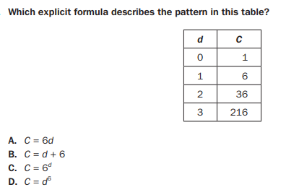 | 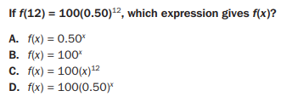
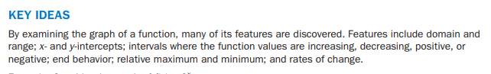
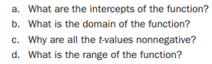
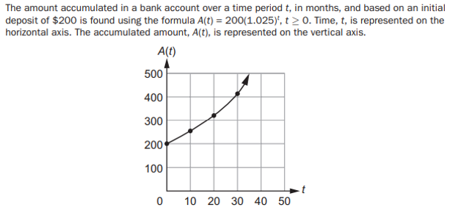

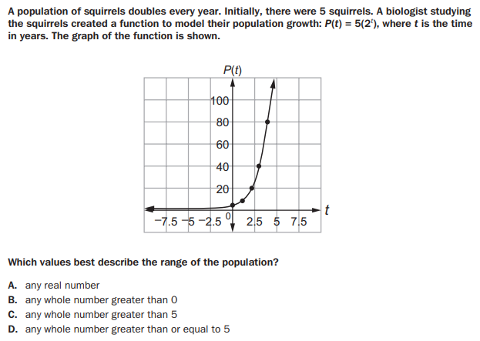

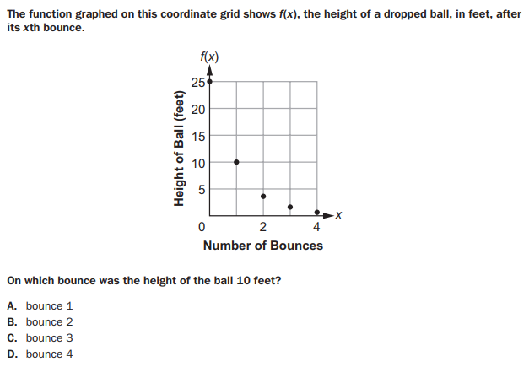

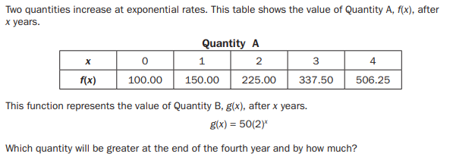
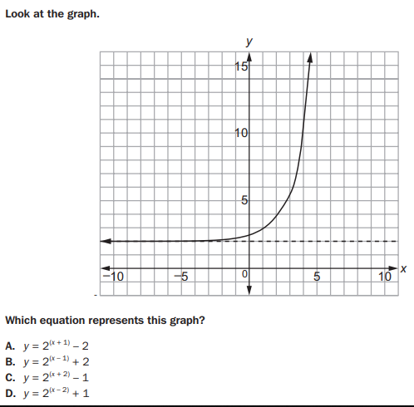
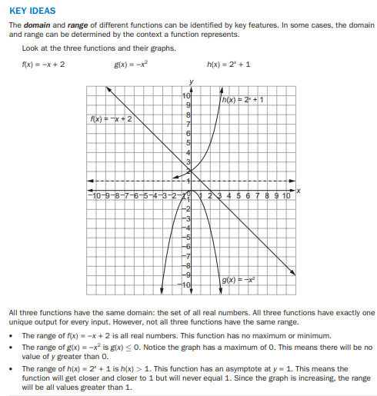

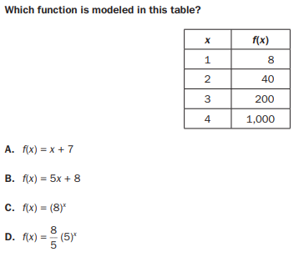 | 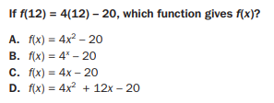
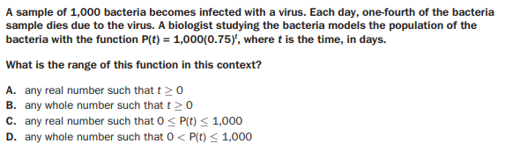
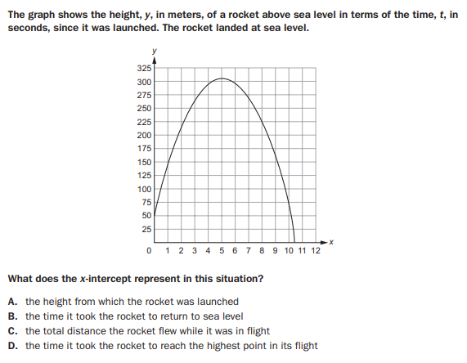

Functions Standards: F.LE. 1 – F.LE.5

Important Tips
- Examine function values carefully.
- Remember that a linear function has a constant rate of change.
- Keep in mind that growth rates are modeled with exponential functions.
- Quadratic functions decrease and increase.
- Remember that the elements of the domain and the values obtained by substituting them into the function rule form the coordinates of the points that lie on the graph of a function. The domain and range can also be determined by examining the graph of a function, by looking for asymptotes on the graph of an exponential function, or by looking for endpoints or continuity for linear, quadratic, and exponential functions, or the vertex of a quadratic function.
- Be familiar with important features of a function, such as intercepts, domain, range, minimum and maximums, end behavior, asymptotes, and periods of increasing and decreasing values.

Review Examples

Linear Function Example:
Recognizing linear and exponential growth rates is key to modeling a quantitative relationship.
Given a table of values, look for a rate of change in the y, or f(x), column.
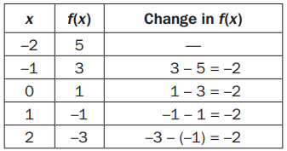
The following table shows a constant rate of change, –2, in the f(x) column for each unit change in the independent variable x. When the change in f(x) is constant, we use a linear model, f(x) = ax + b, where a represents the constant rate of change and b the y-intercept.
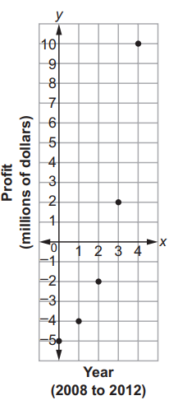
The function is f(x) = –2x + 1.

Exponential Function Example:
Given the graph below, compare the coordinates of points to determine whether there is either linear or exponential growth.

The points represent the profit/loss of a new company over its first 5 years, from 2008 to 2012. The company started out $5,000,000 in debt. After 5 years, it had a profit of $10,000,000. From the arrangement of the points, the pattern does not look linear. We can check by considering the coordinates of the points and using a table of values.
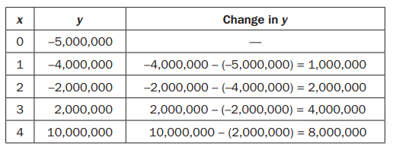
The y changes are not constant for equal x intervals. However, the ratios of successive differences are equal. Therefore, it is confirmed that this is not linear.
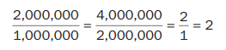
Having a constant percent for the growth rate for equal intervals indicates exponential growth. The
relationship can be modeled using an exponential function.

Comparing Functions Examples:

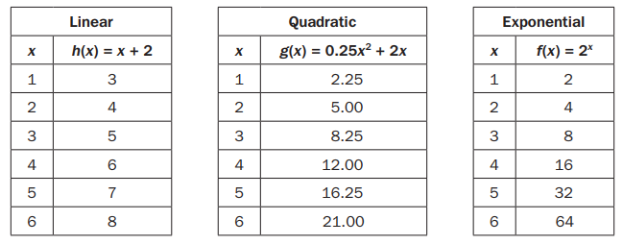

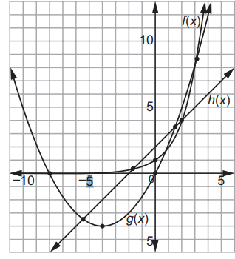

In the table, h(1) is greater than g(1), which is greater than f(1). The tables can be used to see that each function increases, and the graph provides a visual of the intervals each function decreases or increases. Notice how f(x) increases at a higher rate than g(x) and both increase at a higher rate than h(x). The graph also displays that g(x) is the only function that decreases and increases. The axis of symmetry passes through the vertex, which is the point where g(x) begins to increase as x increases.

How does the growth rate of the function f(x) = 2x + 3 compare with g(x) = 0.5x² – 3? Use a graph to explain your answer.
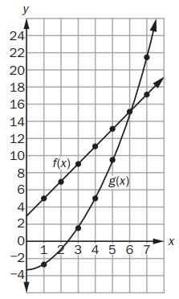

The graph of f(x) increases at a constant rate because it is linear.
The graph of g(x) increases at an increasing rate because it is quadratic.
The graphs can be shown to intersect at (6, 15), and the value of g(x) is greater than the value of f(x) for x > 6.

Parameters Example:
Parameters may be expressed as letters when a relationship is generalized, they are not variables. A parameter as a constant term generally affects the intercepts of a function. If the parameter is a coefficient, in general it will affect the rate of change. Below are several examples of specific parameters.

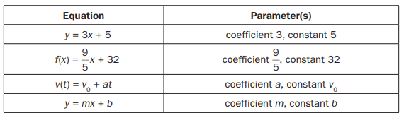

Review Questions

- Erin had a container of water that was partially full. She used a garden hose to fill the rest of the container at a constant rate. Erin recorded the height of the water at the end of different intervals of time in this table.

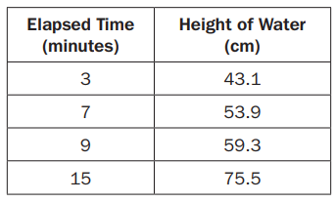
Part A: What was the height, in centimeters, of the water before Erin started to fill the rest of the container? Round your answer to the nearest whole number. Write your answer in the space provided.
Part B: After how many minutes was the height of the water double what it was before Erin started to fill the rest of the container? Round your answer to the nearest whole minute. Write your answer in the space provided.
Part C: Does this equation model this relationship: h = 2.7m + 35? Explain why or why not. Write your answer in the space provided.
Part A ____________________________________________________________________________________________________________________________________________________________________________________________________
Part B ____________________________________________________________________________________________________________________________________________________________________________________________________
Part C ____________________________________________________________________________________________________________________________________________________________________________________________________
Part D ____________________________________________________________________________________________________________________________________________________________________________________________________

2. The swans on Elsworth Pond have been increasing in number each year. Felix has been keeping track, and so far he has counted 2, 4, 7, 17, and 33 swans each year for the past 5 years.
a. Make a scatter plot of the swan populations.
Solution:
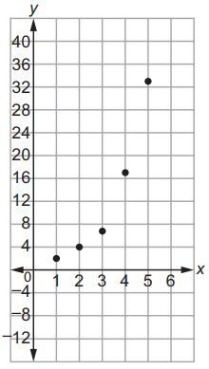
b. What type of model would be a better fit, linear or exponential? Explain your answer.

c. How many swans should Felix expect next year if the trend continues? Explain your answer.

3. Given the sequence 7, 10, 13, 16, ...
a. Does it appear to be linear or exponential?

b. Determine a function to describe the sequence.

c. What would the 20th term of the sequence be?

4. Which scatter plot BEST represents a model of linear growth?
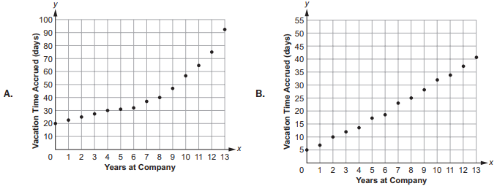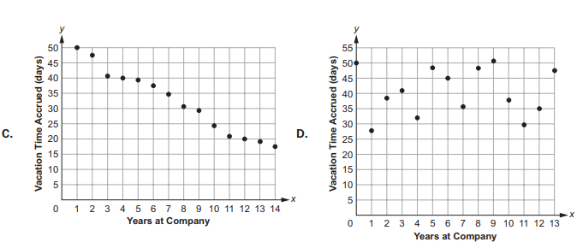

5. Which scatter plot BEST represents a model of exponential growth?
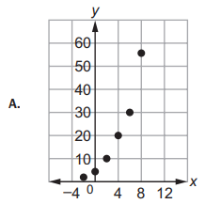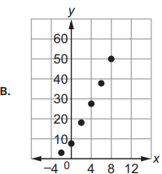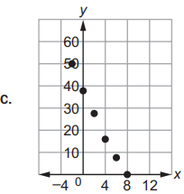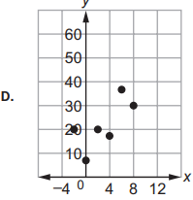

6. Which table represents an exponential function?
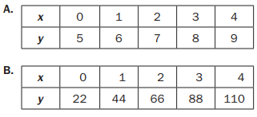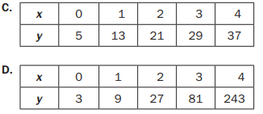

7. A table of values is shown for f(x) and g(x).
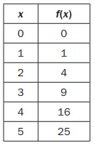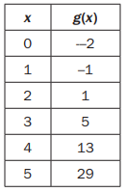
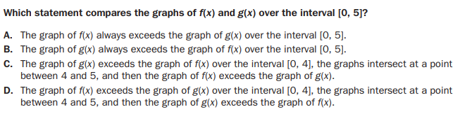

8. Which statement is true about the graphs of exponential functions?
A. The graphs of exponential functions never exceed the graphs of linear and quadratic functions.
B. The graphs of exponential functions always exceed the graphs of linear and quadratic functions.
C. The graphs of exponential functions eventually exceed the graphs of linear and quadratic functions.
D. The graphs of exponential functions eventually exceed the graphs of linear functions but not quadratic functions.

9. Which statement BEST describes the comparison of the function values for f(x) and g(x)?
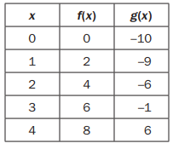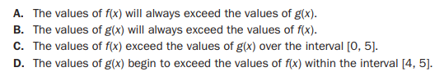

10. Alice finds that her flower bulbs multiply each year. She started with just 24 tulip plants. After one year she had 72 plants. Two years later she had 120. Find a linear function to model the growth of Alice’s bulbs.
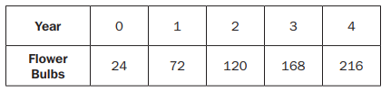
If the parent function is f(x) = mx + b, what is the value of the parameter m for the line passing through the points (–2, 7) and (4, 3)?

- – 9 B. $-\frac{3}{2}$ C. – 2 D. $-\frac{2}{3}$

11. Consider this function for cell duplication. The cells duplicate every minute
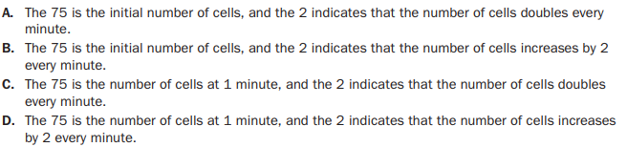

Function Standards: F.BF. 1 – F.BF.3

