Enzymes Review Sheet
SC.912.L.18.11 Explain the role of enzymes as catalysts that lower the activation energy of biochemical reactions. Identify factors, such as pH and temperature, and their effect on enzyme activity.
Enzymes are substances that increase the speed of chemical reactions. Most enzymes are proteins. Enzymes are catalysts, which are substances that reduce the activation energy of a chemical reaction. An enzyme increases the speed of a chemical reaction by reducing the activation energy of the reaction. Enzymes help organisms maintain homeostasis. Without enzymes, chemical reactions would not occur quickly enough to sustain life.
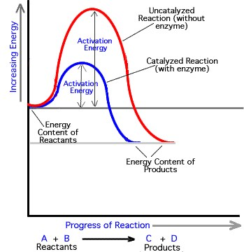
Enzymes assist biochemical reactions by bringing key molecules together. A substance on which an enzyme acts during a chemical reaction is called a substrate. Enzymes act only on specific substrates. An enzyme’s shape determines its activity. Typically, an enzyme is a large protein with one or more deep folds on its surface. These folds form pockets called active sites. As shown in the figure below, an enzyme’s substrate fits into the active site. An enzyme acts only on a specific substrate because only that substrate fits into its active site. Your body’s cells contain many different enzymes, and each enzyme catalyzes a different chemical reaction.
Figure 1
Any factor that changes the shape of an enzyme can affect the enzyme’s activity. For example, enzymes operate most efficiently within a certain range of temperatures. Temperatures outside this range can either break or strengthen some of the enzyme’s bonds, changing its shape. Moreover, each enzyme operates best within a certain range of pH values. A pH value outside this range can cause bonds in an enzyme to break, reducing the enzyme’s effectiveness.

- Using figure 1, how does using an enzyme in a chemical reaction impact the reaction?

- Does it speed up or slow down the reaction?

- How does the enzyme impact activation energy?

- Based on your answers to questions a and b, what do you think the term “catalyzed” means?
- Define the following terms: protein, enzyme, activation energy, catalyst.

- Using Figure 2(a) and 1(b): What are two conditions that affect enzyme function?
- Provide an explanation for why human enzymes function best at 40⁰C but enzymes from hot springs bacterium works best at 70⁰C.

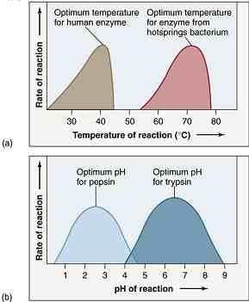
- What do you think happens to the human enzyme when the temperature increases to 45⁰C?
Figure 2

- In figure 2(b) you can see two different enzymes, why do you think they work best at different pH levels?

- The human body can reuse some of the enzymes found in raw fruits and vegetables. Why is this not the case for cooked fruits and vegetables?

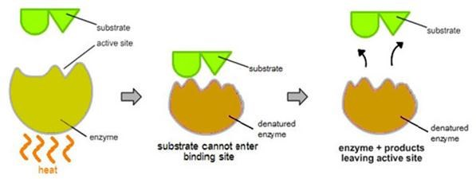
- Figure 3 above shows what happens to an enzyme when exposed to heat. Using the figure above, describe how the structure of enzyme effect the enzymes ability to function properly.

- An enzyme is at an optimum pH and temperature. What is another way that you could catalyze the reaction?
- Increase the pH
- Increase the temperature
- Increase the activation energy
- Increase the concentration of enzyme

- As food travels through the digestive system, it is exposed to a variety of pH levels. The stomach has a pH of 2 due to the presence of hydrochloride acid (HCl), and the small intestine has a pH ranging from 7 to 9. HCl converts pepsinogen into pepsin, an enzyme that digests proteins in the stomach. Which of the following most likely happens to pepsin as it enters the small intestine?
- It becomes inactive.
- It begins to replicate.
- It's shape changes to engulf large proteins.
- It's activity increases to digest more proteins.

- The enzyme lactase will break down the sugar lactose into which of the following components?
a. monosaccharides
b. nucleic acids
Figure 3
c. amino acids
d. phospholipids

- In living cells, enzymes act as catalysts, which may reduce the amount of activation energy required for a chemical reaction to occur. In the graphs below, pathway x is a solid line representing the uncatalyzed reaction. The dotted line shows the catalyzed reaction. Which graph best illustrates the changes in a reaction when the catalyst reduces the amount of energy required?
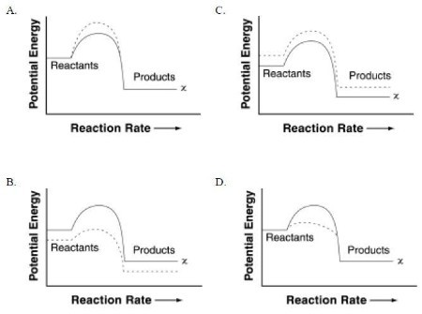
- What will most likely happen if an appropriate enzyme is added to a chemical reaction?
- The reaction rate will increase.
- The equilibrium of the reaction will be maintained.
- The reaction rate will decrease.
- The reaction will stop.

- The human body maintains a temperature of around 98.6 degrees at all times. Enzymes are involved in almost every chemical reaction in the body. Which of the following describes the connection between these two statements?
a. Enzymes function best at a specific temperature.
b. The body needs to be warm to prevent hypothermia.
c. The body is kept relatively warm to prevent too much enzyme action.
d. There is no connection between the two statements.

