**DNA Replication**

**SC.912.L.16.3:** Describe the basic process of DNA replication and how it relates to the transmission and conservation of the genetic information.

**SC.912.L.16.9:** Explain how and why the genetic code is universal and is common to almost all organisms.

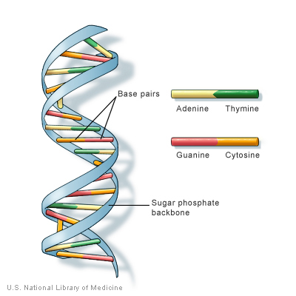DNA, or deoxyribonucleic acid, is the hereditary material in humans and almost all other organisms. Nearly every cell in a person’s body has the same DNA. Most DNA is located in the cell nucleus, but a small amount of DNA can also be found in the mitochondria.

The information in DNA is stored as a code made up of four chemical bases: adenine (A), guanine (G), cytosine (C), and thymine (T). Human DNA consists of about 3 billion bases, and more than 99 percent of those bases are the same in all people. The order, or sequence, of these bases determines the information available for building and maintaining an organism, similar to the way in which letters of the alphabet appear in a certain order to form words and sentences.

DNA bases pair up with each other, A with T and C with G, to form units called base pairs. Each base is also attached to a sugar molecule and a phosphate molecule. Together, a base, sugar, and phosphate are called a nucleotide. Nucleotides are arranged in two long strands that form a spiral called a double helix. The structure of the double helix is somewhat like a ladder, with the base pairs forming the ladder’s rungs and the sugar and phosphate molecules forming the vertical sidepieces of the ladder. An important property of DNA is that it can replicate, or make copies of itself. Each strand of DNA in the double helix can serve as a pattern for duplicating the sequence of bases. This is critical when cells divide because each new cell needs to have an exact copy of the DNA present in the old cell. Before a cell can reproduce, it must first replicate, or make a copy of, its DNA. DNA replication occurs in the nucleus of eukaryotes. The beauty of this structure is that it can unzip down the middle and each side can serve as a pattern or template for the other side (called semi-conservative replication). However, DNA does not unzip entirely. It unzips in a small area called a replication fork, which then moves down the entire length of the molecule.

Let's look at the details:

* An enzyme makes a groove in the double helix and each side separates
* An enzyme unwinds the double-stranded DNA
* Several small proteins temporarily bind to each side and keep them separated
* An enzyme complex "walks" down the DNA strands and adds new nucleotides to each strand. The nucleotides pair with the complementary nucleotides on the existing stand (A with T, G with C).
* A subunit of the DNA polymerase proofreads the new DNA
* An enzyme seals up the fragments into one long continuous strand
* The new copies automatically wind up again

Different types of cells replicated their DNA at different rates. Some cells constantly divide, like those in your hair and fingernails and bone marrow cells. Other cells go through several rounds of cell division and stop (including specialized cells, like those in your brain, muscle and heart). Finally, some cells stop dividing, but can be induced to divide to repair injury (such as skin cells and liver cells). In cells that do not constantly divide, the cues for DNA replication/cell division come in the form of chemicals. These chemicals can come from other parts of the body (hormones) or from the environment.

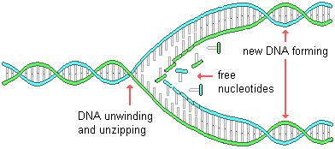

1. Where does replication occur?
2. Why do is it stated that the genetic code is universal?
3. Replicate the following DNA sequence:

ATTCGAATCGGGGTACTA

1. Before a cell can reproduce, it must first replicate. DNA replication is said to be semiconservative because:

A. both RNA and DNA synthesis are involved in the process.

B. part of the telomere is lost during each round of replication.

C. a new double helix contains one old and one new strand.

D. each new strand is complementary, not identical, to its template.

1. Four different segments of a DNA molecule are represented below.



There is an error in the DNA in which molecule?

A. segment 1 only

B. segment 3 only

C. segment 2 and 3

D. segment 2 and 4