Cell Membrane Review
Relate structure to function for the components of plant and animal cells. Explain the role of cell membranes as a highly selective barrier (passive and active transport).
Cell Membrane (Active & Passive Transport)
Cells share common structural features, including an outer boundary called the cell membrane. The cell membrane encloses the cell and separates the cell interior, called the cytoplasm, from its surroundings. The membrane is selectively permeable and able to regulate what enters and exits the cell, thus facilitating the transport of materials needed for survival.
Movement across the cell membrane that does not require energy from the cell is called passive transport. One kind of passive transport, diffusion, is the movement of a substance from an area of high concentration to an area of lower concentration caused by the random motion of particles of the substance. The diffusion of water through a selectively permeable membrane is called osmosis. In facilitated diffusion, a carrier protein transports a substance across the cell membrane down the concentration gradient of the substance.
Active transport is the movement of a substance against the concentration gradient of the substance. Active transport requires cells to use energy. In animal cells, the sodium potassium pump uses energy supplied by ATP to transport sodium ions out of the cell and potassium ions into the cell. During endocytosis, substances are moved into a cell by a vesicle that pinches off from the cell membrane. During exocytosis, substances inside a vesicle are released from a cell as the vesicle fuses with the cell membrane.
- Describe the term "semi-permeable" (or "selectively-permeable) membrane. Why is it important?

- Describe the differences between endocytosis and exocytosis.

- List two (2) similarities and two (2) differences between passive transport and active transport and give 2 examples of each.
Similarities:

Differences:

Osmosis
Cells are affected by their external environments. One factor that can affect cells is the relative concentrations of dissolved particles on either side of the cell membrane. The direction of water movement across the cell membrane (by osmosis) depends on the relative concentrations of free water molecules in the cytoplasm and in the fluid outside the cell. There are three possibilities for the direction of water movement:
1. Water moves out. When water diffuses out of the cell, the cell shrinks. A solution that causes a cell to shrink because of osmosis is called a hypertonic solution. If the fluid outside the cell has a higher concentration of dissolved particles than the cytoplasm has, then the outside fluid also has a lower concentration of free water molecules than the cytoplasm.
2. Water moves in. When water diffuses into the cell, the cell swells. A solution that causes a cell to swell because of osmosis is called a hypotonic solution. If the fluid outside the cell has a lower concentration of dissolved particles than the cytoplasm has, then the outside fluid also has a higher concentration of free water molecules than the cytoplasm.
3. No net water movement. If the cytoplasm and the fluid outside the cell have the same concentration of free water molecules, water diffuses into and out of the cell at equal rates. This results in no net movement of water across the cell membrane, and the cell stays the same size—a state of equilibrium. A solution that produces no change in cell volume because of osmosis is called an isotonic solution.
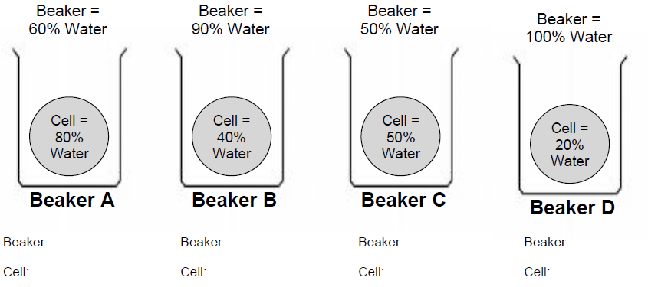
  - For the following diagrams, draw arrows that show the direction that water diffuses (concentration gradient) through the membrane. Label the beaker and cell in each diagram as either hypertonic, hypotonic, or isotonic.

- A person with swollen gums rinses his mouth with warm salt water, and the swelling decreases. Which of the following has occurred?
  - The swollen gums have absorbed the saltwater solution.
  - The saltwater solution lowers the temperature of the water in the gums.
  - The salt in the solution has moved against the concentration gradient.
  - The water in the gums has moved out due to the high concentration of salt in the solution.

- The cell membrane of the red blood cell will allow water, oxygen, and carbon dioxide to pass through. Because other substances are blocked from entering, this membrane is called
- perforated
- semi-permeable
- non-conductive
- permeable

- An osmosis investigation was conducted using chicken eggs to represent cells with semipermeable membranes. The mass of each egg was measured to determine how much water diffused into or out of the eggs. The eggs were first soaked in vinegar to dissolve the shell. Each egg was then placed in one of three different solutions for 24 hours. The table below shows the results of the investigation.
Osmosis in Cells
Solution | Average Mass of Eggs Before Soaking (grams) | Average Mass of Eggs After Soaking (grams) | Difference in Average Mass (grams) | Percent Change in Average Mass
Vinegar (95% water) | 71.2 | 98.6 | 27.4 | +38.5
Corn Syrup (5% water) | 98.6 | 64.5 | 34.1 | -34.6
Distilled Water (100% water) | 64.5 | 105.3 | 40.8 | +63.3

- Based on this experiment, which of the following should be inferred about cells with semipermeable membranes?
- Substances other than water may also cross the cell membrane.
- Substances other than water may block pores in the cell membrane.
- Water enters the cell when placed in environments of high water concentration.
- Water leaves the cell when placed in environments with a low concentration of solutes

