Cell Cycle and Mitosis Review Sheet
Describe the cell cycle, including the process of mitosis. Explain the role of mitosis in the formation of new cells and its importance in maintaining chromosome number during asexual reproduction.
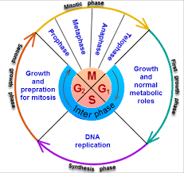
Explain the relationship between mutation, cell cycle, and uncontrolled cell growth potentially leading to cancer.

The Cell Cycle

Interphase: G1,S,G2

G1 phase: During this time, the cell grows in preparation for DNA replication.
S phase: S phase, or synthesis, is the phase of the cell cycle when DNA is replicated. Replication allows each cell to have the same genetic make-up. After replication the cell contains twice its normal number of chromosomes.
G2 phase: In G2 a cell can check to make sure that the entirety of its DNA has been properly duplicated. This is the cell's final chance to grow before it is split into two independent cells.
Mitosis: Mitosis simply refers to a type of cell division in which one cell (the parent) divides to produce two new cells (the daughters) that are genetically identical to itself. In the context of the cell cycle, mitosis refers to just one part of the overall division process. The large majority of the cell divisions that happens in your body involves mitosis. The “goal” of mitosis is to pass on identical genetic information.
Phases of mitosis: Mitosis consists of four basic phases: prophase, metaphase, anaphase, and telophase. These phases occur in order, and cytokinesis - the process of dividing the cell contents to make two new.
Prophase: The mitotic spindle starts to form, the chromosomes start to condense, and the nucleolus disappears. The mitotic spindle begins to capture and organize the chromosomes.
Metaphase. The spindle has captured all the chromosomes and lined them up at the middle of the cell, ready to divide
Anaphase. The sister chromatids separate from one another and are pulled towards opposite poles of the cell.
Telophase. The spindle disappears, a nuclear membrane re-forms around each set of chromosomes, and a nucleolus reappears in each new nucleus. The chromosomes also start to decondense. In telophase, the cell is nearly finished dividing, and it starts to re-establish normal internal structures as cytokinesis takes place.
Cytokinesis in animal and plant cells.
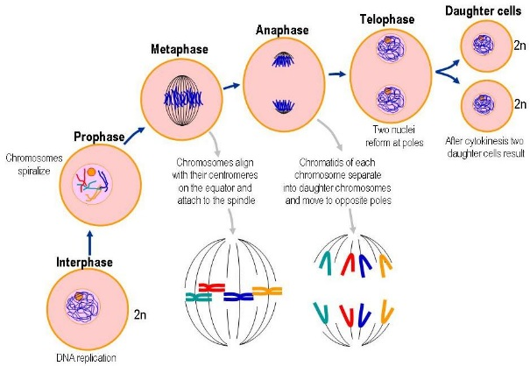
Cytokinesis in an animal cell: an actin ring around the middle of the cell pinches inward, creating an indentation called the cleavage furrow. Cytokinesis in a plant cell: the cell plate forms down the middle of the cell, creating a new wall that partitions it in two.
Cell cycle and Cancer
The cell cycle, the process by which cells progress and divide, lies at the heart of cancer. In normal cells, the cell cycle is controlled by a complex series of signaling pathways by which a cell grows, replicates its DNA and divides. In the case of cancer, the controls that regulate cell multiplication, break down. This may be due to a mutation. When cells lose control and keep dividing; not knowing when to stop, they keep forming new cells creating cancer.

 | Phase | Description | Picture
Interphase | G1 |  | 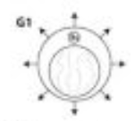
 |  | Synthesis of DNA | 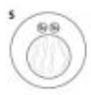
 |  | Growing and preparing for Mitosis | 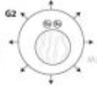
Mitosis |  | DNA condenses into chromosomes and nuclear membrane disappears | 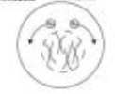
 | Metaphase |  | 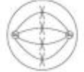
 | Anaphase |  | 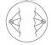
 |  | Nuclear membrane reappears and begins to divide | 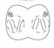
 |  | Cell completely divides into two new identical daughter cells | 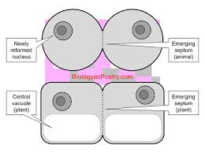

- Which of the following phrases best describes cancer?
  - absence of cyclins in the DNA
  - multiple gene mutations on a chromosome of DNA
  - uncontrolled cell growth caused by mutations in genes that control the cell cycle
  - presence of genetic defects caused by hereditary disorders
- Which of the following phases of mitosis is represented by the diagram below?
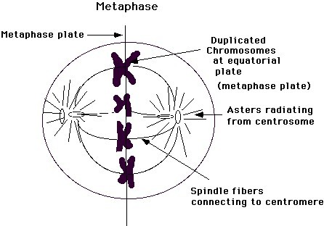
  - Prophase
  - metaphase
  - anaphase
  - telophase

- The diagram below shows two strawberry plants.
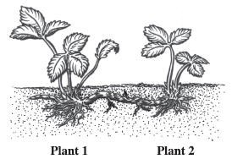
Plant 2 is produced asexually from Plant 1. If the leaf cells of Plant 1 have 56 chromosomes, how many chromosomes will be found in the leaf cells of Plant 2?
  - 14
  - 28
  - 56
  - 112

