AMERICAN LITERATURE
STUDY TIPS AND ACTIVITIES
FOR
GEORGIA MILESTONES
(April 27, 28, 29)

Included in this study guide packet are information about the EOC, tips for test taking, terms that students should be familiar with, and activities to help students practice for various types of questions. Feel free to access other study aids, such as, USA TEST Prep, GA DOE website with a Study Resource Guide and other websites with study questions.

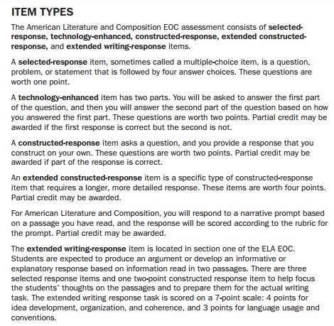
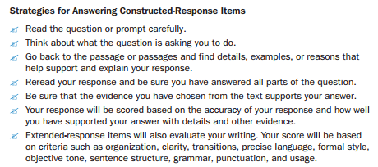
READING LITERARY TEXT
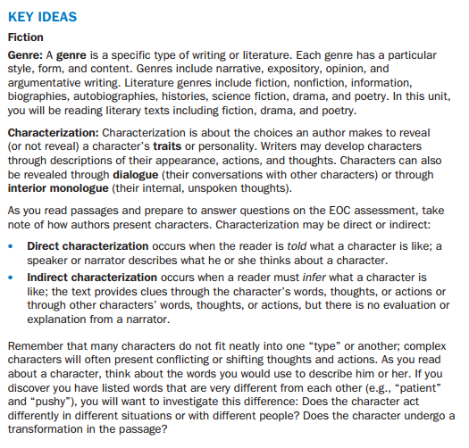
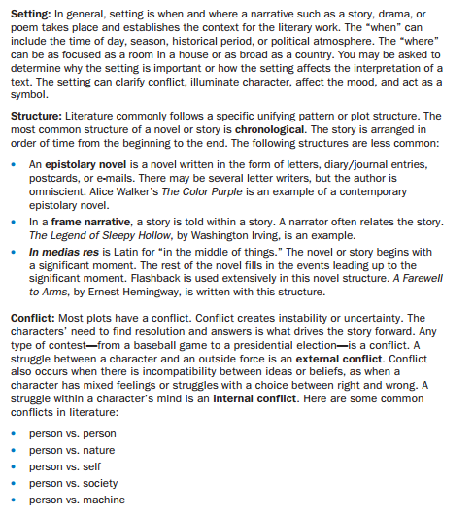

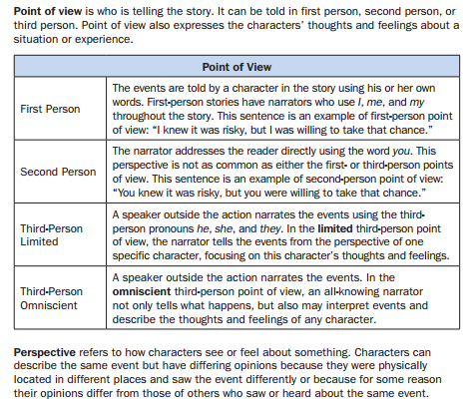
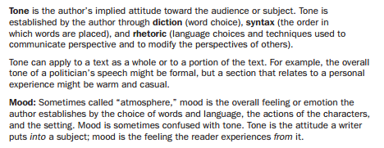
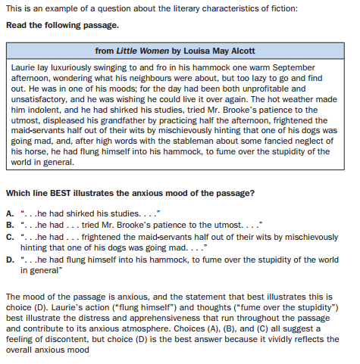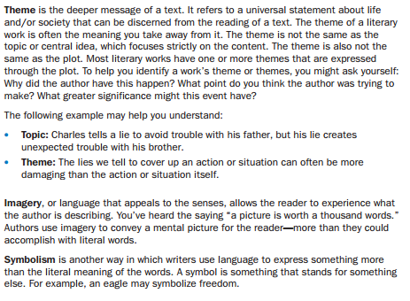
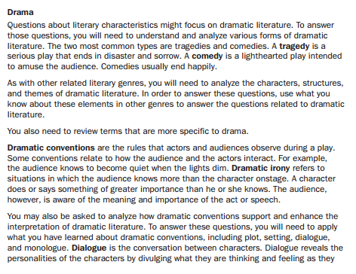

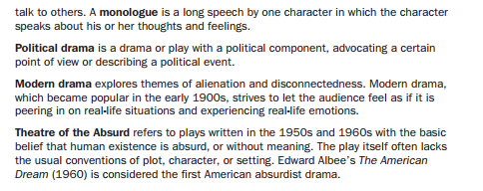
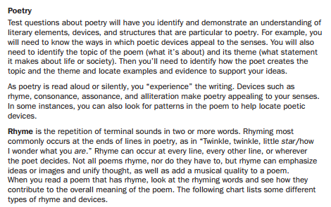
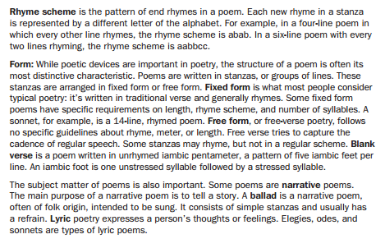
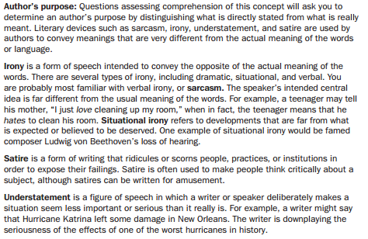
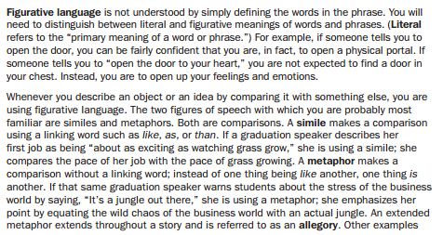
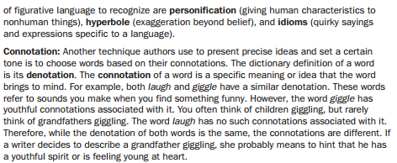

PRACTICE 1

The Eyes Have It
by PHILIP K. DICK
IT WAS quite by accident I discovered this incredible invasion of Earth by lifeforms from another planet. As yet, I haven’t done anything about it; I can’t think of anything to do. I wrote to the Government, and they sent back a pamphlet on the repair and maintenance of frame houses. Anyhow, the whole thing is known; I’m not the first to discover it. Maybe it’s even under control.
I was sitting in my easy-chair, idly turning the pages of a paperbacked book someone had left on the bus, when I came across the reference that first put me on the trail. For a moment I didn’t respond. It took some time for the full import to sink in. After I’d comprehended, it seemed odd I hadn’t noticed it right away.
The reference was clearly to a nonhuman species of incredible properties, not indigenous to Earth. A species, I hasten to point out, customarily masquerading as ordinary human beings. Their disguise, however, became transparent in the face of the following observations by the author. It was at once obvious the author knew everything. Knew everything — and was taking it in his stride. The line (and I tremble remembering it even now) read:
… his eyes slowly roved about the room.
Vague chills assailed me. I tried to picture the eyes. Did they roll like dimes? The passage indicated not; they seemed to move through the air, not over the surface. Rather rapidly, apparently. No one in the story was surprised. That’s what tipped me off. No sign of amazement at such an outrageous thing. Later the matter was amplified.
… his eyes moved from person to person.
There it was in a nutshell. The eyes had clearly come apart from the rest of him and were on their own. My heart pounded and my breath choked in my windpipe. I had stumbled on an accidental mention of a totally unfamiliar race. Obviously non-Terrestrial. Yet, to the characters in the book, it was perfectly natural — which suggested they belonged to the same species.
And the author? A slow suspicion burned in my mind. The author was taking it rather too easily in his stride. Evidently, he felt this was quite a usual thing. He made absolutely no attempt to conceal this knowledge. The story continued:
… presently his eyes fastened on Julia.
Julia, being a lady, had at least the breeding to feel indignant. She is described as blushing and knitting her brows angrily. At this, I sighed with relief. They weren’t all non-Terrestrials. The narrative continues:
… slowly, calmly, his eyes examined every inch of her.
Great Scott! But here the girl turned and stomped off and the matter ended. I lay back in my chair gasping with horror. My wife and family regarded me in wonder.
“What’s wrong, dear?” my wife asked.
I couldn’t tell her. Knowledge like this was too much for the ordinary run-of-the-mill person. I had to keep it to myself. “Nothing,” I gasped. I leaped up, snatched the book, and hurried out of the room.
IN THE garage, I continued reading. There was more. Trembling, I read the next revealing passage:
… he put his arm around Julia. Presently she asked him if he would remove his arm. He immediately did so, with a smile.
It’s not said what was done with the arm after the fellow had removed it. Maybe it was left standing upright in the corner. Maybe it was thrown away. I don’t care. In any case, the full meaning was there, staring me right in the face.
Here was a race of creatures capable of removing portions of their anatomy at will. Eyes, arms — and maybe more. Without batting an eyelash. My knowledge of biology came in handy, at this point. Obviously they were simple beings, uni-cellular, some sort of primitive single-celled things. Beings no more developed than starfish. Starfish can do the same thing, you know.
I read on. And came to this incredible revelation, tossed off coolly by the author without the faintest tremor:
… outside the movie theater we split up. Part of us went inside, part over to the cafe for dinner.
Binary fission, obviously. Splitting in half and forming two entities. Probably each lower half went to the cafe, it being farther, and the upper halves to the movies. I read on, hands shaking. I had really stumbled onto something here. My mind reeled as I made out this passage:
… I’m afraid there’s no doubt about it. Poor Bibney has lost his head again.
Which was followed by:
… and Bob says he has utterly no guts.
Yet Bibney got around as well as the next person. The next person, however, was just as strange. He was soon described as:
… totally lacking in brains.
THERE was no doubt of the thing in the next passage. Julia, whom I had thought to be the one normal person, reveals herself as also being an alien life form, similar to the rest:
… quite deliberately, Julia had given her heart to the young man.
It didn’t relate what the final disposition of the organ was, but I didn’t really care. It was evident Julia had gone right on living in her usual manner, like all the others in the book. Without heart, arms, eyes, brains, viscera, dividing up in two when the occasion demanded. Without a qualm.
… thereupon she gave him her hand.
I sickened. The rascal now had her hand, as well as her heart. I shudder to think what he’s done with them, by this time.
… he took her arm.
Not content to wait, he had to start dismantling her on his own. Flushing crimson, I slammed the book shut and leaped to my feet. But not in time to escape one last reference to those carefree bits of anatomy whose travels had originally thrown me on the track:
… her eyes followed him all the way down the road and across the meadow.
I rushed from the garage and back inside the warm house, as if the accursed things were following me. My wife and children were playing Monopoly in the kitchen. I joined them and played with frantic fervor, brow feverish, teeth chattering.
I had had enough of the thing. I want to hear no more about it. Let them come on. Let them invade Earth. I don’t want to get mixed up in it.
I have absolutely no stomach for it.

Directions: Use the above text to answer the following questions.
1. Which of these BEST describes how the author establishes the tone of the passage?
A. He creates a sense of calm by using literal language in a figurative way.
B. He creates discomfort by describing an ordinary situation in ambiguous terms.
C. He creates a sense of escalating dread with word choice and the use of connotation.
D. He creates humor by blurring the distinction between literal and figurative language.

2. Read the last sentence of the passage.
I have absolutely no stomach for it.
In the context of the rest of the story, which literary device is the author using in
this sentence?
A. irony
B. satire
C. personification
D. understatement

3. Which of these BEST describes why the author uses multiple settings?
A. to suggest both joy and sorrow
B. to suggest both light and shadow
C. to suggest both motion and tranquility
D. to suggest both connection and isolation

4. (Technology Enhanced) This question has two parts. Answer Part A, and then answer Part B.
Part A
How does the book the narrator is reading initially make him feel?
A. content
B. doubtful
C. frightened
D. thankful

Part B
Which sentence from the passage BEST supports the answer in Part A?
A. As yet, I haven’t done anything about it; I can’t think of anything to do.
B. Anyhow, the whole thing is known; I’m not the first to discover it.
C. After I’d comprehended, it seemed odd I hadn’t noticed it right way.
D. My heart pounded and my breath choked in my windpipe.

5. Constructed-Response
Describe the state of mind of the narrator at the conclusion of the passage. Support your answer with details from the text. Write your answer on the lines provided.

READING INFORMATIONAL TEXT
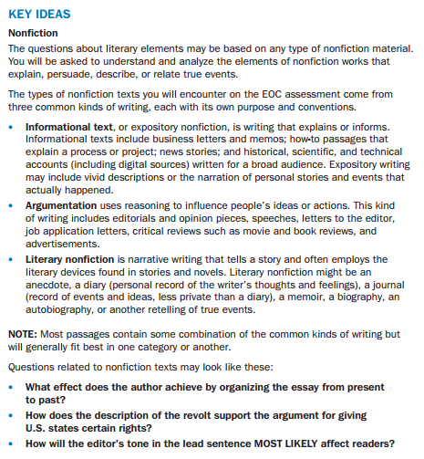

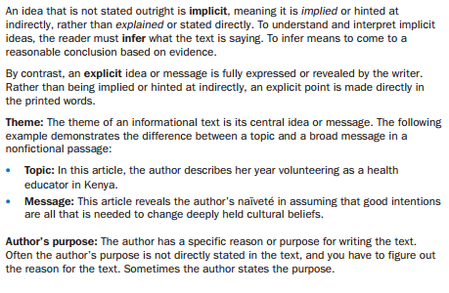
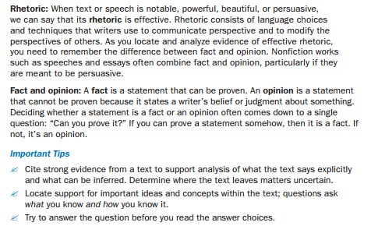
Speech by Ronald Reagan on the 40th Anniversary of D-Day
We're here to mark that day in history when the Allied armies joined in battle to reclaim this continent to liberty. For 4 long years, much of Europe had been under a terrible shadow. Free nations had fallen, Jews cried out in the camps, millions cried out for liberation. Europe was enslaved, and the world prayed for its rescue. Here in Normandy the rescue began. Here the Allies stood and fought against tyranny in a giant undertaking unparalleled in human history.

We stand on a lonely, windswept point on the northern shore of France. The air is soft, but 40 years ago at this moment, the air was dense with smoke and the cries of men, and the air was filled with the crack of rifle fire and the roar of cannon. At dawn, on the morning of the 6th of June, 1944, 225 Rangers jumped off the British landing craft and ran to the bottom of these cliffs. Their mission was one of the most difficult and daring of the invasion: to climb these sheer and desolate cliffs and take out the enemy guns. The Allies had been told that some of the mightiest of these guns were here and they would be trained on the beaches to stop the Allied advance.

The Rangers looked up and saw the enemy soldiers -- the edge of the cliffs shooting down at them with machineguns and throwing grenades. And the American Rangers began to climb. They shot rope ladders over the face of these cliffs and began to pull themselves up. When one Ranger fell, another would take his place. When one rope was cut, a Ranger would grab another and begin his climb again. They climbed, shot back, and held their footing. Soon, one by one, the Rangers pulled themselves over the top, and in seizing the firm land at the top of these cliffs, they began to seize back the continent of Europe. Two hundred and twenty-five came here. After 2 days of fighting, only 90 could still bear arms.

Behind me is a memorial that symbolizes the Ranger daggers that were thrust into the top of these cliffs. And before me are the men who put them there.

These are the boys of Pointe du Hoc. These are the men who took the cliffs. These are the champions who helped free a continent. These are the heroes who helped end a war.

Gentlemen, I look at you and I think of the words of Stephen Spender's poem. You are men who in your ``lives fought for life . . . and left the vivid air signed with your honor.''

I think I know what you may be thinking right now -- thinking ``we were just part of a bigger effort; everyone was brave that day.'' Well, everyone was. Do you remember the story of Bill Millin of the 51st Highlanders? Forty years ago today, British troops were pinned down near a bridge, waiting desperately for help. Suddenly, they heard the sound of bagpipes, and some thought they were dreaming. Well, they weren't. They looked up and saw Bill Millin with his bagpipes, leading the reinforcements and ignoring the smack of the bullets into the ground around him.

Lord Lovat was with him -- Lord Lovat of Scotland, who calmly announced when he got to the bridge, ``Sorry I'm a few minutes late,'' as if he'd been delayed by a traffic jam, when in truth he'd just come from the bloody fighting on Sword Beach, which he and his men had just taken.

There was the impossible valor of the Poles who threw themselves between the enemy and the rest of Europe as the invasion took hold, and the unsurpassed courage of the Canadians who had already seen the horrors of war on this coast. They knew what awaited them there, but they would not be deterred. And once they hit Juno Beach, they never looked back.

All of these men were part of a rollcall of honor with names that spoke of a pride as bright as the colors they bore: the Royal Winnipeg Rifles, Poland's 24th Lancers, the Royal Scots Fusiliers, the Screaming Eagles, the Yeomen of England's armored divisions, the forces of Free France, the Coast Guard's ``Matchbox Fleet'' and you, the American Rangers.

Forty summers have passed since the battle that you fought here. You were young the day you took these cliffs; some of you were hardly more than boys, with the deepest joys of life before you. Yet, you risked everything here. Why? Why did you do it? What impelled you to put aside the instinct for self-preservation and risk your lives to take these cliffs? What inspired all the men of the armies that met here? We look at you, and somehow we know the answer. It was faith and belief; it was loyalty and love.

The men of Normandy had faith that what they were doing was right, faith that they fought for all humanity, faith that a just God would grant them mercy on this beachhead or on the next. It was the deep knowledge -- and pray God we have not lost it -- that there is a profound, moral difference between the use of force for liberation and the use of force for conquest. You were here to liberate, not to conquer, and so you and those others did not doubt your cause. And you were right not to doubt.

You all knew that some things are worth dying for. One's country is worth dying for, and democracy is worth dying for, because it's the most deeply honorable form of government ever devised by man. All of you loved liberty. All of you were willing to fight tyranny, and you knew the people of your countries were behind you.

The Americans who fought here that morning knew word of the invasion was spreading through the darkness back home. They fought -- or felt in their hearts, though they couldn't know in fact, that in Georgia they were filling the churches at 4 a.m., in Kansas they were kneeling on their porches and praying, and in Philadelphia they were ringing the Liberty Bell.

Something else helped the men of D-day: their rockhard belief that Providence would have a great hand in the events that would unfold here; that God was an ally in this great cause. And so, the night before the invasion, when Colonel Wolverton asked his parachute troops to kneel with him in prayer he told them: Do not bow your heads, but look up so you can see God and ask His blessing in what we're about to do. Also that night, General Matthew Ridgway on his cot, listening in the darkness for the promise God made to Joshua: ``I will not fail thee nor forsake thee.''

These are the things that impelled them; these are the things that shaped the unity of the Allies.

When the war was over, there were lives to be rebuilt and governments to be returned to the people. There were nations to be reborn. Above all, there was a new peace to be assured. These were huge and daunting tasks. But the Allies summoned strength from the faith, belief, loyalty, and love of those who fell here. They rebuilt a new Europe together.

There was first a great reconciliation among those who had been enemies, all of whom had suffered so greatly. The United States did its part, creating the Marshall plan to help rebuild our allies and our former enemies. The Marshall plan led to the Atlantic alliance -- a great alliance that serves to this day as our shield for freedom, for prosperity, and for peace.

In spite of our great efforts and successes, not all that followed the end of the war was happy or planned. Some liberated countries were lost. The great sadness of this loss echoes down to our own time in the streets of Warsaw, Prague, and East Berlin. Soviet troops that came to the center of this continent did not leave when peace came. They're still there, uninvited, unwanted, unyielding, almost 40 years after the war. Because of this, allied forces still stand on this continent. Today, as 40 years ago, our armies are here for only one purpose -- to protect and defend democracy. The only territories we hold are memorials like this one and graveyards where our heroes rest.

We in America have learned bitter lessons from two World Wars: It is better to be here ready to protect the peace, than to take blind shelter across the sea, rushing to respond only after freedom is lost. We've learned that isolationism never was and never will be an acceptable response to tyrannical governments with an expansionist intent.

But we try always to be prepared for peace; prepared to deter aggression; prepared to negotiate the reduction of arms; and, yes, prepared to reach out again in the spirit of reconciliation. In truth, there is no reconciliation we would welcome more than a reconciliation with the Soviet Union, so, together, we can lessen the risks of war, now and forever.

It's fitting to remember here the great losses also suffered by the Russian people during World War II: 20 million perished, a terrible price that testifies to all the world the necessity of ending war. I tell you from my heart that we in the United States do not want war. We want to wipe from the face of the Earth the terrible weapons that man now has in his hands. And I tell you, we are ready to seize that beachhead. We look for some sign from the Soviet Union that they are willing to move forward, that they share our desire and love for peace, and that they will give up the ways of conquest. There must be a changing there that will allow us to turn our hope into action.

We will pray forever that some day that changing will come. But for now, particularly today, it is good and fitting to renew our commitment to each other, to our freedom, and to the alliance that protects it.

We are bound today by what bound us 40 years ago, the same loyalties, traditions, and beliefs. We're bound by reality. The strength of America's allies is vital to the United States, and the American security guarantee is essential to the continued freedom of Europe's democracies. We were with you then; we are with you now. Your hopes are our hopes, and your destiny is our destiny.

Here, in this place where the West held together, let us make a vow to our dead. Let us show them by our actions that we understand what they died for. Let our actions say to them the words for which Matthew Ridgway listened: ``I will not fail thee nor forsake thee.''

Strengthened by their courage, heartened by their value [valor], and borne by their memory, let us continue to stand for the ideals for which they lived and died.

Directions: Use the above text to answer the following questions.
A. What is the MAIN purpose of this speech?
A. Reagan wishes to honor the men who fought on D-Day.
B. Reagan wants to remind people why America joined WWII.
C. Reagan seeks to encourage more people to fight for their country.
D. Reagan is painting a vivid picture of what happened on the shores of Normandy.

Reagan begins by stating, “Here the Allies stood and fought against tyranny in a giant undertaking unparalleled in human history.” He goes on to describe the courage the Rangers showed in fighting to reclaim Europe from enemy forces. The rest of the speech gives reasons to support his attitude. The best answer is A. Answer B is not correct; he describes the good cause the Allies fought for in WWII, but that is not the main purpose of the speech. Answer C is not correct; there is no evidence in the speech to support that answer. Finally, answer D is not correct; while he describes the events of D-Day in great detail, he does so mainly to highlight the men’s valor.

B. What technique does Reagan use effectively to make his point believable?
What would you say in response to this question? Whether this questions was followed by selected-response answers to choose from or if it required a short response, the best way to figure it out is to look at how Reagan supports his statement “Here the Allies stood and fought against tyranny in a giant undertaking unparalleled in human history.” What he does is give a detailed account of the harrowing experience the Allies faced on the beach of Normandy forty years ago. He describes how the men did not give up even as their comrades fell beside them. And he refers to them as “the heroes who helped end the war.” You should have come to the conclusion that he uses the rhetoric or a pathos appeal to make his point believable. No matter what type of question this would have been you can think about the answer before reading the answer choices so that you have something to match your answer against.

C. Constructed Response: What is Reagan’s point of view about why the Allies stormed the beach? What other related points does he focus on?
Sample Response: In his speech, Ronald Reagan brings up the important question of why the young men risked their lives to reclaim Normandy. He acknowledges that the men had so much to lose (“You were young the day you took these cliffs; some of you were hardly more than boys, with the deepest joys of life before you. Yet you risked everything here.”) He then asserts that the reason they did so was because they had faith in and loyalty to their country. They believed that the cause they fought for was just (“You were here to liberate, not to conquer, and so you and those others did not doubt your cause.”) and that their fellow Americans supported them. He commends the Allies for being willing to sacrifice their lives for democracy and liberty and says that the American people will not forget their sacrifice.

PRACTICE 2

Susan B. Anthony on Women’s Right to Vote
1 Friends and fellow citizens: I stand before you tonight under indictment for the alleged crime of having voted at the last presidential election, without having a lawful right to vote. It shall be my work this evening to prove to you that
in thus voting, I not only committed no crime, but, instead, simply exercised my citizen’s rights, guaranteed to me and all United States citizens by the National Constitution, beyond the power of any state to deny.

2 The preamble of the Federal Constitution says:

3 “We, the people of the United States, in order to form a more perfect union, establish justice, ensure domestic tranquility, provide for the common defense, promote the general welfare, and secure the blessings of liberty to
ourselves and our posterity, do ordain and establish this Constitution for the United States of America.”

4 It was we, the people; not we, the white male citizens; nor yet we, the male citizens; but we, the whole people, who formed the Union. And we formed it, not to give the blessings of liberty, but to secure them; not to the half of
ourselves and the half of our posterity, but to the whole people—women as well as men. And it is a downright mockery to talk to women of their enjoyment of the blessings of liberty while they are denied the use of the only means of
securing them provided by this democratic-republican government—the ballot.

5 For any state to make sex a qualification that must ever result in the disfranchisement of one entire half of the people, is to pass a bill of attainder, or, an ex post facto law, and is therefore a violation of the supreme law of the land. By it the blessings of liberty are forever withheld from women and their female posterity.

6 To them this government has no just powers derived from the consent of the governed. To them this government is not a democracy. It is not a republic. It is an odious aristocracy; a hateful oligarchy1 of sex; the most hateful aristocracy ever established on the face of the globe; an oligarchy of wealth, where the rich govern the poor. An oligarchy of learning, where the educated govern the ignorant. . . .

7 Webster, Worcester, and Bouvier2 all define a citizen to be a person in the United States, entitled to vote and hold office.

8 The only question left to be settled now is: Are women persons? And I hardly believe any of our opponents will have the hardihood to say they are not. Being persons, then, women are citizens; and no state has a right to make any law, or to enforce any old law, that shall abridge their privileges or immunities. Hence, every discrimination against women in the constitutions and laws of the several states is today null and void, precisely as is every one against Negroes.

Susan B. Anthony – 1873
1 oligarchy: a country ruled by a small group of people 2 Webster, Worcester, and Bouvier are authors of American dictionaries.

Directions: Use the above text to answer the following questions.
6. In which paragraph does Susan B. Anthony explicitly argue that prohibiting women from voting is illegal?
A. paragraph 3
B. paragraph 4
C. paragraph 5
D. paragraph 6

7. What argument does Susan B. Anthony make with her statements about “oligarchy” in paragraph 6?
A. Denying women equality is undemocratic.
B. The very definition of citizenship entitles women to vote.
C. She would not have been fined for voting had she been a man.
D. Dictionaries provide the best resources for settling the voting issue.

8. Read this sentence from paragraph 3.
“We, the people of the United States, in order to form a more perfect union,
establish justice, ensure domestic tranquility, provide for the common defense,
promote the general welfare, and secure the blessings of liberty to ourselves and our
posterity, do ordain and establish this Constitution for the United States of America.”
Which phrase from the sentence does Anthony MOST passionately analyze and evaluate throughout the speech?
A. We, the people
B. domestic tranquility
C. the general welfare
D. the blessings of liberty

9. Constructed-Response
How does Susan B. Anthony connect the idea of “aristocracy” to the U.S. government of her day?
Support your answer with details from the text.

WRITING – ARGUMENTATIVE AND INFORMATIVE TEXT
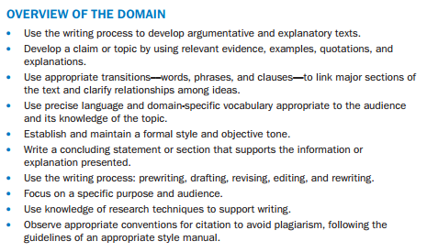
Types of Writing
- Argumentative Writing – try to influence readers to share a point of view or to take some action
- Make a Claim – clearly state the position you take on a particular issue. It can’t be just a statement of fact. Claim argues for one side of a controversy or a question to which there is no definitive answer.
- Example: Edgar Allan Poe was the most innovative writer of the nineteenth century, evidenced by how he mastered prose and poetry, pioneered the short story, and laid the groundwork for twentieth century literature.
- Support the Claim – effective support should include strong evidences as facts, quotations and opinions from experts, and logical reasoning.
- Use relevant evidence to support each point you make
- Show connections between the claim and the reasons, between the reasons and the evidence, and between the claim and any counterclaims you might include
- Use logical reasoning. Appeal to logic (reason), ethics (sense of right and wrong), and emotion (likes, dislikes, hopes, guilt) – logos, ethos, and pathos
- Answer counterclaims (opposing arguments). Show the limitations of your opponents position.

Practice 3

License the Cats
One of the animal kingdom’s foremost examples of grace, majesty, and power is the Bengal tiger of India. The Indian subcontinent is home to fewer than 2,000 of these animals now, whereas a century ago, their population was 20 times that number. You may ask whether that reduction is as serious as it appears on its surface, and, paradoxically, the answer is both yes and no.
The Indian population of tigers is not the end of the matter; in fact, to find a tiger, you can do no better than to look to the United States, which is host to thousands of tigers. Some live in zoos for everyone to see, but more than 12,000 are owned privately as pets; 4,000 of those pets are in one state—Texas. Texas is one of 15 states that require a license to own not only Bengal tigers, but other big cats, such as leopards, lions, and panthers. Sixteen states have no restrictions on ownership whatsoever, nor do they even keep records of ownership. Nineteen states, however, ban ownership altogether.
It is relatively easy to buy a big cat in the United States; in some markets, they cost about the same as a thoroughbred dog—$400 to $1,000. If the new owner’s state is one of the 19 that ban ownership, it is relatively easy to buy an animal out of state and bring the animal across state lines. Because of the ease of making a purchase, animals often end up with people not fully prepared for the responsibility this kind of pet entails. Too often the novelty of a cute little cub wears thin after several hours of posting photos on social media or after the animal has gained hundreds of pounds. Providing food and shelter become onerous, to say the least. Many owners find themselves facing a real dilemma: devote the time and resources necessary to attend to the animal, or diminish the quality of its life through reduced living space and nutrition. (A 400-pound Siberian–Bengal tiger was once found in a New York City apartment.) People frequently try to divest themselves of the problem by getting rid of the cat. However, zoos generally don’t want more tigers, because they already have an optimal number. Even at low prices, few buyers exist for problem cats, some of whom may have harmed or frightened neighbors.
However, in some venues it is possible for exotic cats to live well, or even thrive, under the stewardship of a human. Some wealthy individuals devote large tracts of land to wildlife preserves, hosting giraffes, elephants, and antelope, as well as big cats.
The answer to the problem lies in licensing. The states requiring licensing currently vary widely in terms of requirements placed on the owner and the amount of oversight by the licensing agency. The ideal process should be costly for both the buyer and the state. With rigorous screening beforehand and a substantial licensing fee, in combination with diligent monitoring after the fact, it would be possible for these proud beasts to live well and also ensure that the species not become extinct.
Don’t put a bell on the cat. License its owner.

Ban Ownership of Exotic Pets
In taking a stand against private ownership of “lions and tigers and bears,” it would be tempting to bring up the case of the Ohio man who released over 50 exotic “pets” into his neighborhood. But the argument does not need to rely on the actions of an outlier, a tragically disturbed man with an inordinate attraction to out-of-the-ordinary pets. A ban on owning such animals considers two dimensions: man and beast.
On one side of the argument is man’s innate fallibility. Too frequently, people become owners of big cats because they can be relatively inexpensive to obtain, often under $1,000. But buying, for example, a Bengal tiger, is the easy part. Soon owners find themselves with responsibility for 700 pounds of wild instinct. Unable to satisfy the animal’s needs for space and nutrition, which often happens, the owner becomes, in effect, an abuser. I’m sure that no one goes into such a relationship with that intent, but animal-rights caseworkers verify that result in a shocking number of instances.
Another side of the argument is the problem of the potential extinction of certain species of animal. Let’s focus on the Bengal tiger as representative of the issue. The native habitat of the Bengal tiger is India, which is now home to fewer than 2,000 Bengals, or 5% of what it supported a hundred years ago. The population is dangerously low, due to loss of habitat, hunting, and trading on the exotic animals market. Not counting those in zoos, the United States is home to about 12,000 privately owned Bengals. Former boxing champion Mike Tyson, for example, once owned three Royal Bengals. With a ban on private ownership and with the right kinds of wildlife management in a suitable habitat, this proud animal could once again roam at will in wild places rather than find its way to the head of an endangered species list.
Citizens of the United States are often wary of governmental prohibitions or restrictions; it is one of the ways we reinforce and practice our freedoms. But there is always that line somewhere between the needs or desires of the individual and the welfare of the larger community. When Mike Tyson failed to acquire proper licensing for his tigers, which he claimed cost him $4,000 per month to maintain, U.S. authorities seized them and relocated them to a refuge in Colorado. Such enforcement might be considered unduly expensive, and even oppressive. It would be far better to institute an outright ban on private ownership of the big cats or other similar exotic animals, with exceptions for zoos or compounds with a certified educational or environmental focus. As a matter of fact, that is already the case in 19 of our 50 states, and the people of those states do not feel that their freedoms have been threatened.
Ban private ownership of exotic pets.
Directions: Use the two passages above to answer the following questions.
10. Based on the proposal in “License the Cats,” what should a person have in order to get a license to own a tiger?
A. a loving home
B. vast resources
C. access to a zoo
D. an appreciation of animals

11. Why does the author of “Ban Ownership of Exotic Pets” refuse to use the details in the first paragraph to oppose exotic pet ownership?
A. They are not typical of pet owner behavior.
B. The circumstances are too grisly to relate.
C. The information supports unlimited access.
D. It is not known whether any of the animals were tigers.

12. Constructed-Response
On which point do the authors of both articles MOSTLY agree? Use details from BOTH articles to support your answer.

13. Extended Writing-Response
Now that you have read “License the Cats” and “Ban Ownership of Exotic Pets” and answered some questions about what you have read, create a plan for and write your argumentative essay.

The media have often shown pictures of glamorous movie stars walking pet cheetahs or other exotic animals around their grounds. At other times, the media have revealed shocking stories of events gone horribly wrong with a pet tiger, orangutan, or some other unusual pet. Some people say that ownership of these kinds of animals must be banned. Others just advocate more supervision. Weigh the claims on both sides, and then write an argumentative essay, in your own words, supporting one side of the debate in which you argue EITHER that people have the right to own exotic animals OR that exotic animals are not pets. Be sure to use information from BOTH passages in your argumentative essay.

- Informative – (also called explanatory or expository writing) inform readers or to explain a topic
- Explain how something works
- Tell why something happened
- Show how two or more things are alike or different
- Point out a problem and give possible solutions
- Define what something is
- Remember to: organize your ideas so they build on each other
- Remember to: use formatting (headings and subheadings) to aid reader in comprehension
- Remember to: use graphics and multimedia when possible
- Remember to: support topic with relevant facts, concrete details and quotations
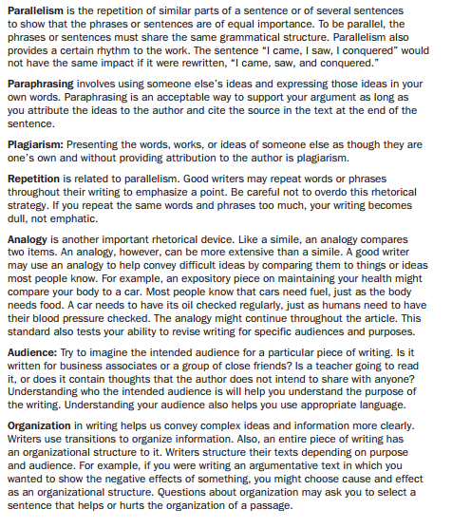

Language
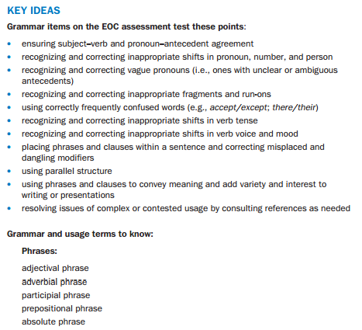
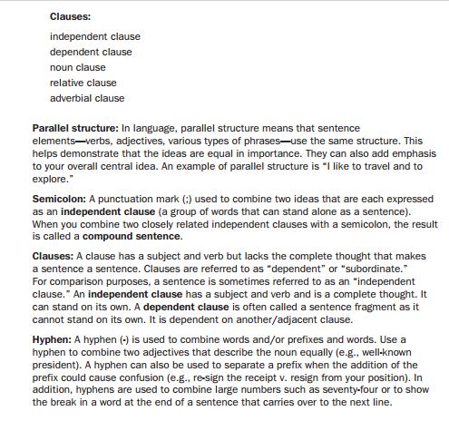
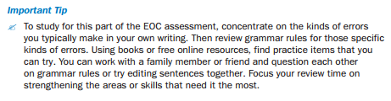

Practice 4
A Fable
By Mark Twain
1 Once upon a time an artist who had painted a small and very beautiful picture placed it so that he could see it in the mirror. He said, “This doubles the distance and softens it, and it is twice as lovely as it was before.”
2 The animals out in the woods heard of this through the housecat, who was greatly admired by them because he was so learned, and so refined and civilized, and so polite and high-bred, and could tell them so much which they didn’t know before, and were not certain about afterward. They were much excited about this new piece of gossip, and they asked questions, so as to get at a full understanding of it. They asked what a picture was, and the cat explained.
3 “It is a flat thing,” he said; “wonderfully flat, marvelously flat, enchantingly flat and elegant. And, oh, so beautiful!”
4 That excited them almost to a frenzy, and they said they would give the world to see it. Then the bear asked:
5 “What is it that makes it so beautiful?”
6 “It is the looks of it,” said the cat.
7 This filled them with admiration and uncertainty, and they were more excited than ever. Then the cow asked:
8 “What is a mirror?”
9 “It is a hole in the wall,” said the cat. “You look in it, and there you see the picture, and it is so dainty and charming and ethereal and inspiring in its unimaginable beauty that your head turns round and round, and you almost swoon with ecstasy.”
10 The donkey had not said anything as yet; he now began to throw doubts. He said there had never been anything as beautiful as this before, and probably wasn’t now. He said that when it took a whole basketful of sesquipedalian adjectives to whoop up a thing of beauty, it was time for suspicion.
11 It was easy to see that these doubts were having an effect upon the animals, so the cat went off offended. The subject was dropped for a couple of days, but in the meantime curiosity was taking a fresh start, and there was a revival of interest perceptible. Then the animals assailed the donkey for spoiling what could possibly have been a pleasure to them, on a mere suspicion that the picture was not beautiful, without any evidence that such was the case. The donkey was not troubled; he was calm, and said there was one way to find out who was in the right, himself or the cat: he would go and look in that hole, and come back and tell what he found there. The animals felt relieved and grateful, and asked him to go at once—which he did.
12 But he did not know where he ought to stand; and so, through error, he stood between the picture and the mirror. The result was that the picture had no chance, and didn’t show up. He returned home and said:
13 “The cat lied. There was nothing in that hole but a donkey. There wasn’t a sign of a flat thing visible. It was a handsome donkey, and friendly, but just a donkey, and nothing more.”
14 The elephant asked:
15 “Did you see it good and clear? Were you close to it?”
16 “I saw it good and clear, O Hathi, King of Beasts. I was so close that I touched noses with it.”
17 “This is very strange,” said the elephant; “the cat was always truthful before—as far as we could make out. Let another witness try. Go, Baloo, look in the hole, and come and report.”
18 So the bear went. When he came back, he said:
19 “Both the cat and the donkey have lied; there was nothing in the hole but a bear.”
20 Great was the surprise and puzzlement of the animals. Each was now anxious to make the test himself and get at the straight truth. The elephant sent them one at a time.
21 First, the cow. She found nothing in the hole but a cow.
22 The tiger found nothing in it but a tiger.
23 The lion found nothing in it but a lion.
24 The leopard found nothing in it but a leopard.
25 The camel found a camel, and nothing more.
26 Then Hathi was angry, and said he would have the truth, if he had to go and fetch it himself. When he returned, he abused his whole subjectry for liars, and was in an unappeasable fury with the moral and mental blindness of the cat. He said that anybody but a near-sighted fool could see that there was nothing in the hole but an elephant.
27 MORAL, BY THE CAT:
28 You can find in a text whatever you bring, if you will stand between it and the mirror of your imagination. You may not see your ears, but they will be there.
Directions: Use the above passage to answer the questions below.
14. Read this sentence from paragraph 26.
When he returned, he abused his whole subjectry for liars, and was in an unappeasable fury with the moral and mental blindness of the cat.
Which of these BEST paraphrases the underlined portion of the sentence in contemporary English?
A. “When he returned, he scolded all of his subjects, calling them liars . . .”
B. “When he returned, he subjected the others to a barrage of angry lies . . .”
C. “When he returned, he clarified their misperceptions so they would believe his lies . . .”
D. “When he returned, he banished his subjects from the woods, assuming they had lied . . .”

15. Read paragraphs 9 and 10.
“It is a hole in the wall,” said the cat. “You look in it, and there you see the picture, and it is so dainty and charming and ethereal and inspiring in its unimaginable beauty that your head turns round and round, and you almost swoon with ecstasy.”
The donkey had not said anything as yet; he now began to throw doubts. He said there had never been anything as beautiful as this before, and probably wasn’t Now. He said that when it took a whole basketful of sesquipedalian adjectives to whoop up a thing of beauty, it was time for suspicion.
Which of these is the MOST LIKELY meaning of the underlined word?
A. concise
B. inapplicable
C. long-winded
D. well-informed

16. Constructed-Response
Review the fable and concentrate on the word mirror. How does the meaning of the word change depending on the context of the speaker? Use information from the fable to support your answer.
-

ANSWER GUIDE – Selected Response
Number | Text | Answer | Explanation
1 | The Eyes Have It | D | The correct answer is choice (D) He creates humor by blurring the distinction between literal and figurative language. The protagonist mistakes common figures of speech for literal descriptions and concludes as a result that Earth is being invaded by aliens. Choice (A) is incorrect because no sense of calm is constructed in the passage. Choice (B) is incorrect because there is no ambiguity in the narrative. The way that the protagonist is misinterpreting what he reads is plain. Choice (C) is not altogether incorrect, but it is not the most precise answer.
2 | The Eyes Have It | A | The correct answer is choice (A) irony. The passage’s final sentence is ironic because the protagonist correctly uses the very sort of figurative language he has been misinterpreting in his reading. Choice (B) is somewhat correct, but it is not the most precise answer. Choice (C) is incorrect because the statement is not ascribing human qualities to the stomach. Choice (D) is incorrect because the sentence is a figurative exaggeration, not an understatement.
3 | The Eyes Have It | D | The correct answer is choice (D) to suggest both connection and isolation. The protagonist begins his reading in his house, surrounded by his family. Then he goes out to his garage, where he is alone. When his fear reaches a peak, he returns to his house and is again with his family. Choices (A), (B), and (C) are incorrect because the multiple settings in the story do not suggest a division between any of the opposing conditions named in those choices.
4 | The Eyes Have It | Part A: C  Part B: D | The correct answers are (C) frightened, and (D) My heart pounded and my breath choked in my windpipe. The main character becomes increasingly alarmed by what he reads in his book, which is made clear by numerous examples from what he is reading. The answer choice for Part B of this item shows text from the passage that supports this conclusion. In Part A, Choice (A) is incorrect because the speaker becomes increasingly agitated as the passage progresses. Choice (B) is incorrect because rather than show any doubt, the speaker is confident that something truly terrible is happening. Choice (D) is incorrect as there is no indication that the speaker feels thankful for the book he is reading, especially as his panic escalates. The incorrect options in Part B support incorrect answers in Part A.
6 | Susan B. Anthony | C | The correct answer is choice (C) paragraph 5. In that paragraph, Anthony cites specific legal principles that make the denial of women’s suffrage illegal. Choices (A), (B), and (D) are incorrect because nowhere in those referenced paragraphs does she explicitly cite a law or legal principle that is violated by the denial of women’s right to vote.
7 | Susan B. Anthony | A | The correct answer is choice (A) Denying women equality is undemocratic. She argues that legal inequality between men and women goes against the principles of democracy. Choices (B), (C), and (D) are incorrect because although they correctly state or infer aspects of Anthony’s viewpoint, they do not address the content of paragraph 6.
8 | Susan B. Anthony | A | The correct answer is choice (A) We, the people. This is the concept that Anthony uses to make her central argument that women are people as defined in the Constitution and deserve full equality. Choices (B), (C), and (D) are incorrect because Anthony does not dissect these concepts to nearly the same degree as she does the concept of women being “people.”
10 | License the Cat/Ban Ownership of Exotic Birds | B | The correct answer is choice (B) vast resources. Choice (A) is incorrect because the animals need more than a loving home. Choice (C) is incorrect because the author states that zoos often don’t want these animals. Choice (D) is incorrect because an appreciation of animals alone will not qualify you for a license
11 | License the Cat/Ban Ownership of Exotic Birds | A | The correct answer is choice (A) They are not typical of pet owner behavior. Although this extreme situation did occur, it is not representative of most cases. Choice (B) is inaccurate since no grisly details are included. Choice (C) indicates that the situation would actually support the opposing argument. Choice (D) is irrelevant to the argument.
14 | Mark Twain Fable | A | The correct answer is choice (A) “When he returned, he scolded all of his subjects, calling them liars . . .” The remainder of the sentence makes it clear that the elephant was angry at those around him, and choice (A) gives the most likely reason. Choices (B), (C), and (D) all contain descriptions that do not fit well with the content of the second part of the compound sentence.
15 | Mark Twain Fable | C | The correct answer is choice (C) longwinded. The statement by the cat in the previous paragraph is packed with gushing and unnecessary adjectives. Answers (A) and (D) are incorrect because those adjectives have positive connotations, and the donkey’s statement is obviously not meant to be complimentary. Answer (B) is incorrect because the context gives no indication that the cat is not adequately communicating what he means to say.

SCORING RUBRICS FOR CONSTRUCTED RESPONSE QUESTIONS
AND
SCORING RUBRICS FOR EXTENDED RESPONSE QUESTIONS – can be found in the DOE Milestone Resource/Study Guide (pg. 89-90)

Number | Text | Points | POSSIBLE RESPONSE
5 | The Eyes Have It | 2 | The narrator’s state of mind at the end of the story is mixed. He is frightened, as evidenced by his feverish brow and chattering teeth. He is also desperately trying to distance himself from his fear by playing a board game with his family. He has resigned himself to his belief that Earth is being invaded. Finally, he is at his wit’s end, as shown by his final statement, in which he makes it plain that he wants nothing to do with any of what he has “discovered.”
 |  | 1 | The narrator is frightened and frantic. He is trying to calm his fear by  playing a game with his family.
 |  | 0 | The narrator is nervous for no reason.
9 | Susan B. Anthony | 2 | For Anthony, the term “aristocracy” is synonymous with the term “oligarchy,” rule by the few. She believes that it defines the U.S. system of government more accurately than do the terms “republic” and “democracy.” She sees several intertwined types of aristocracy/ oligarchy running both government and society and feels that the one defined by the different rights and privileges accorded both sexes is the most “odious.”
 |  | 1 | Anthony believes that oligarchy and aristocracy are the same thing. You can tell because she uses the terms interchangeably in paragraph 6.
 |  | 0 | Anthony thinks that everyone is second-class.
12 | License the Cat/Ban the Ownership of Exotic Pets | 2 | Both authors agree that exotic pet ownership is a big job. So big, in fact, that countless people fail miserably at it, to the detriment of the animal itself. The animals become a great drain on the owners when they grow from playful cubs to 700-pound meat eaters. And the response is all too often to deny the animals the basics of an existence.
 |  | 1 | They both think that not all people are right to have an exotic pet. They are way too much work for some people.
 |  | 0 | Celebrities often have exotic pets.
16 | Mark Twain’s Fable | 2 | In paragraph 1, mirror means mirror, a reflective device. However, the cat doesn’t know about reflections and sees it as a hole in the wall through which the painting can be seen. Similarly, the donkey did not know about reflections, but stood in such a way that the mirror was another donkey to him. The same definition of mirror followed for the other animals.
 |  | 1 | The mirror sometimes was a way to see a painting, or a hole in the wall, or the animal looking at it.
 |  | 0 | The animals showed that they didn’t know what the word meant.

EXTENDED RESPONSE ANSWERS – this response would earn the possible number of points (7 out of 7)

Among the many bits of information wafting through the debate about owning exotic pets is the dwindling population of Bengal tigers in their natural habitat: according to License the Cats there are currently “fewer than 2000” Bengal Tigers on the Indian subcontinent where they live. It is stunning to realize that any group of anything so small would be so recognizable throughout the world. A town with fewer than 2000 residents would not even appear on a national map, or some state maps. A widget maker who produces fewer than 2000 widgets each year would not make any Forbes list. But we know Bengal tigers, and because we know them, we want what’s best for them and their cousins, other big cats such as leopards, lions and panthers.

The physician’s creed is to do no harm, and that principle must guide this issue. We can stay true to the creed best by licensing ownership of exotic pets.
Clearly, such a small population of cats could disappear very quickly through natural disasters, overhunting, disease, or other causes. With big cats in safe sanctuaries, we will preserve the species, plain and simple. Laboratories keep strains of deadly viruses alive well after they have been removed as a public threat. We can debate the precise number needed another time, but we would have a supply of breeding stock.

So much for the species, but we also have to do no harm to the individual cat, or bear, or hippo. And we can do that by making exotic pet ownership expensive and highly regulated. A potential owner would have to guarantee the benefits of the pet’s future environment. A Siberian-Bengal tiger living in a two-room apartment in New York City—an actual case referenced in License for Cats!—would not get approved. A 2,000-acre sanctuary might.

The other article, Ban Ownership of Exotic Pets, brings up the case of Mike Tyson to argue that a full ban on exotic pet ownership is needed. However, the article states that “When Mike Tyson failed to acquire proper licensing for his tigers…U.S. authorities seized them.” So even in that case, strict licensing laws solved the problem. This clearly shows that a full ban is unnecessary. Finally, with strict licensing guidelines in place, owners would have to submit to frequent inspections and pay heavy licensing fees which would fund the oversight. Again, we will have done no harm.

