Domain: Algebra Connections to Statistics 15%
1.  S.ID.2 | Anna is planning a winter vacation to a ski resort. The box and whisker plot shows the daily low temperatures for her four potential destinations.  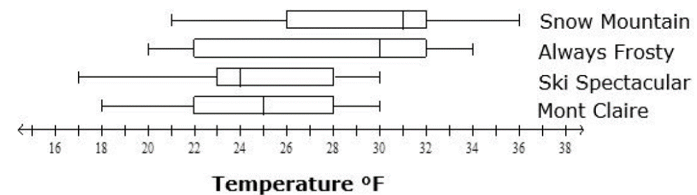  Which destination has a median above 27 degrees with the largest interquartile range?  - Snow Mountain c. Ski Spectacular  - Always Frosty d. Mont Claire
2.  S.ID.3 | Using data from #1, Which ski resort has the most consistent variability for daily low temperatures?  - Snow Mountain c. Ski Spectacular  - Always Frosty d. Mont Claire
3.  S.ID.5 | 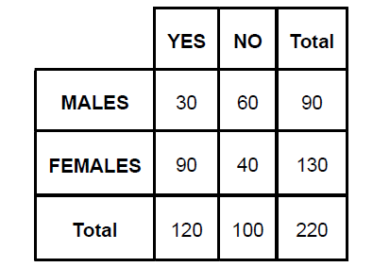  Khloe surveyed the freshmen class about whether or not each classmate had a pet. The table shows the result of her survey.  What is the probability of choosing a pet  Owner given the student is a female freshman?  - 39%  - 59%  - 69%  - 75%
4.  S.ID.7 | The line of best fit for a scatter plot that represents the monthly cost, y, in dollars, of a television subscription package in terms of the number of movie channels, x, is shown.  y = 22.25x + 75.25  What is the meaning of the y-intercept?  - The initial cost of a television subscription package without any movie channels is $22.25.  - The initial cost of a television subscription package without any movie channels is $75.25.  - The increase in monthly cost per movie channel is $22.25.  - The increase in monthly cost per movie channel is $75.25.
5.  S.ID.8 | 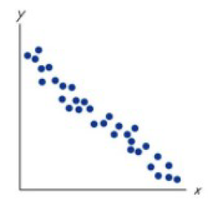  Consider the scatter plot to the below?  What is the estimated correlation coefficient and  what does it indicate about the data?  - The correlation coefficient is approximately 0.85; the data has a strong positive correlation.  - The correlation coefficient is approximately -0.85; the data has a strong negative correlation.  - The correlation coefficient is approximately 0.15; the data has a strong positive correlation.  - The correlation coefficient is approximately -0.15; the data has a strong negative correlation.
6.  S.ID.3 | 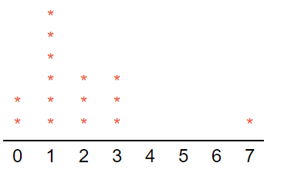  The following data plot shows the number of runs scored by the Frankville Rattlers baseball team in their last 15 games.  If the outlier in the data set was removed,  what would happen to the mean?  - The mean would be increased  - The mean would be reduced  - The mean would not change  - There is no way to determine what would happen to the mean
7.  S.ID.2 | 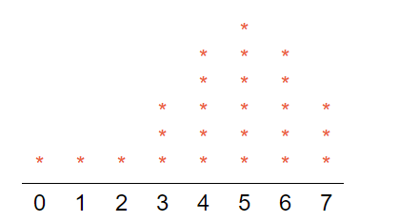  Jim is attempting to learn a new language. He has kept up with the number of hours he has spent studying during each of the last 25 weeks. He used his records to create the dot plot shown below.  Which of the following properly describes  the shape of the data?  - The data is skewed left  - The data is normal, symmetric  - The data is skewed right  - There is not enough information to determine if the data is skewed or normal
8.  S.ID.9 | 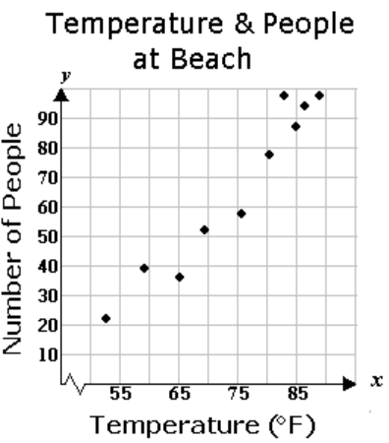  Tony, the lifeguard at Waununa Beach, recorded the temperature and the number of people on his stretch of beach over the course of several weeks. He collected data at noon on Tuesdays and Saturdays during the five weeks between Mother's Day and Father's Day, as shown in the graph below.  Which of the following is a valid conclusion?  - No conclusion can be drawn about the correlation or causation of the temperature and the number of people at the beach.  - There is no correlation between the temperature and the number of people at the beach.  - The increase in temperature caused an increase in the number of people at the beach.  - The increase in the number of people at the beach is correlated to, but not caused by, the increase in temperature.
9.  S.ID. 7 | 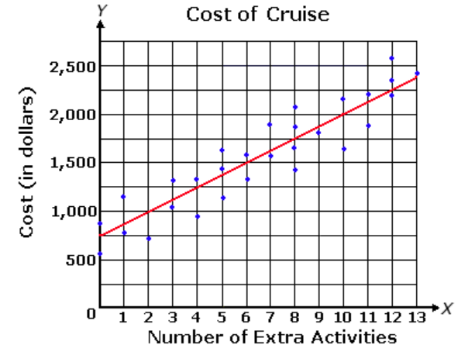  The graph below shows a line of best fit for data collected on the cost of a cruise as a function of the number of extra activities added to the cruise.  The equation of the line of best fit is  $$y=125x+750$$  What does the slope of this line represent?  - The number of activities added  - The overall cost of the cruise  - The cost per activity  - The cost of the cruise without any activities.
10.  S.ID. 5 | A survey was administered to students regarding computer ownership. The results are displayed in the following two-way frequency table.  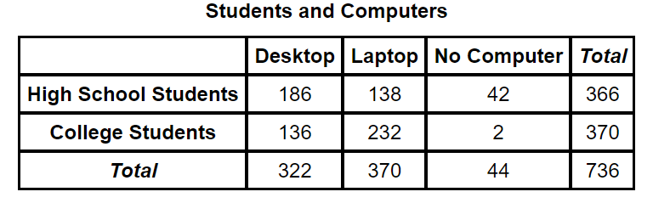  What percentage of surveyed  students own a laptop?  - 62.7%  - 37.3%  c. 5.98%  d. 50.27%

