Domain: Functions 35%
1.  F.IF.7  3 –  – 0  1  –2  7  2 –1  – | Which equation represent the graph of the exponential function given to the right?  - $y={\frac{1}{2}}^{x}+2$  - $y=2^{x}+2$  - $y={\frac{1}{2}}^{x+2}$  - $y=2^{x}-2$
2.  F.BF.1a | Which function represents the data in the table?  x 3 6 10 15  y 2 .5 4 6 8 .5  - $f\left(x\right)=2x+1$ c. $f\left(x\right)=2x -1$  - $f\left(x\right)= \frac{x}{2}-1$d. $f\left(x\right)= \frac{x}{2}+1$
3.  F.BF.3 | Identify the vertex of the quadratic function $f\left(x\right)= {(x+3)}^{2}-4$.  - (3, -4) c. (-3, -4)  - (3, 4) d. $\left(-4, -3\right)$
4.  F.LE.1a | Which scenario represents exponential growth?  - A kudzu vine grows 12 inches per day.  - A candle melts at a rate of 2 mm per minute.  - A population of flies doubles every five days.  - A ball bounces half of its previous distance per bounce.
5.  F.LE.5 | Deborah's weekly salary can be modeled by the function y = 600x + 500, where x represents the number of cars that she sells in one week.  Which describes the meaning of the slope in the equation?  - She makes $500 without selling any cars.  - She makes $600 without selling any cars.  - Deborah's salary increases $500 per car that she sells.  - Deborah's salary increases $600 per car that she sells.
6.  F.IF.9 | The table and graph show two different functions.  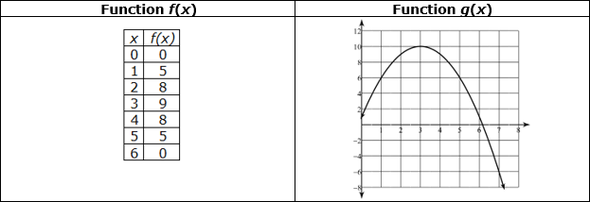  How does the maximum of f(x) compare from the maximum of g(x)?  - f(x) has a maximum value of 9, while g(x) has a maximum value of 3.  - g(x) has a maximum value of 10, while f(x) has a maximum value of 9.  - f(x) has a maximum value of 6, while g(x) has a maximum value of 3  - g(x) has a maximum value of 10, while f(x) has a maximum value of 6.
7.  F.BF.2 | Which of the following attribute describes the sequence: 24, 16, 8, 0?  - The sequence is a discrete linear function  - The sequence is a continuous linear function  - The sequence is a discrete exponential function  - The sequence is a continuous exponential function
8.  F.BF.2 | Which of the following explicit formula describes the sequence: 24, 16, 8, 0?  - $A_{n}=8n+32$  - $A_{n}=-8n+32$  - $A_{n}=24{(-8)}^{n-1}$  - $A_{n}=24{(8)}^{n-1}$
9.  F.IF.5 | 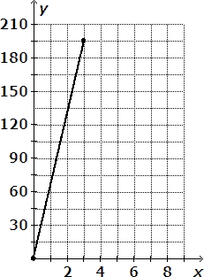  Kiara was driving to visit her grandmother. The graph models her trip  - x represents the time she traveled in hours  - y represents the distance she traveled  What is the reasonable domain for the graph?  - $x≤3$  - $y≤19$  - $0≤x≤3$  - $0≤y≤195$
10.  F.LE.2 | 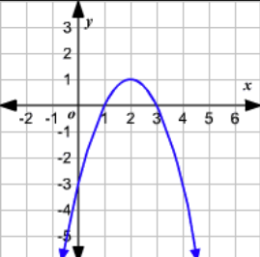  Consider the graph to the right  - $y={\left(x-2\right)}^{2}-1$  - $y={-\left(x+2\right)}^{2}+1$  - $y={\left(x+2\right)}^{2}-1$  - $y={-(x-2)}^{2}+1$
11.  F.IF.6 | 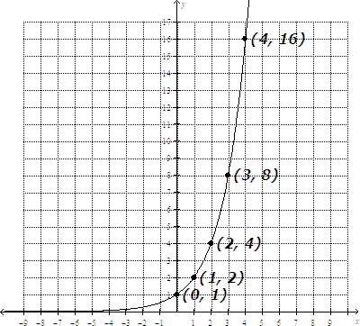  Consider the graph of the exponential function  What is the average rate of change for  the function over the interval [1,4].  - $\frac{-14}{3}$  - $\frac{14}{3}$  - $\frac{3}{14}$  - $\frac{-3}{14}$

