Domain: Equations and Measurement 30%
1.  G.STR.8 | 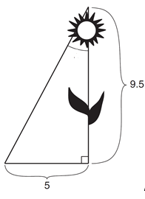  The diagram to the right shows the path a bird flies from the top of a 9.5-foot-tall sunflower to a point on the ground from the base of the sunflower.  To the nearest degree, what is the measure of angle from the  Top of the sunflower and bird pathway?  - $θ={28}^{°}$  - $θ={32}^{°}$  - $θ={58}^{°}$  - $θ={62}^{°}$
2.  G.STR.8 | An oak tree standing tall in the backyard casts a shadow 32 meters long with angle of elevation of ${41}^{°}$, how tall is the tree?  - 15 meters  - 28 meters  - 41 meters  - 59 meters
3.  G.STR.6 | What trigonometric ration is complementary to $\cos{{62}^{°}}$  - $\cos{{62}^{°}}$  - $\cos{{38}^{°}}$  - $\sin{{62}^{°}}$  - $\sin{{38}^{°}}$
4.  G.GMD.1 | 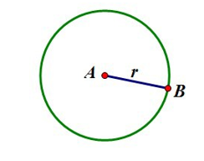  A string is wrapped around Circle A and then cut so that the ends of the string meet to surround Circle A completely.  If you were to cut the string wrapped around circle A in lengths of the exact size of the radius of the circle, how many pieces of the string would you be able to cut? (Round your answer to the nearest whole piece).  - 2 c. 6  - 3 d. 10
5.  G.GMD.1 | 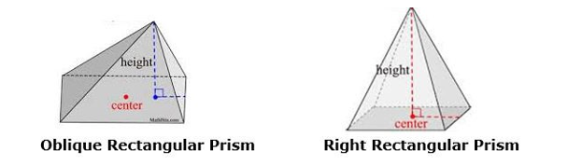  An oblique rectangular prism is similar to the right rectangular prism with the exception that the apex is not over the center of the base.  If an Oblique Rectangular Prism and a Right Rectangular Prism have the same base area and height, what can also be deduced about the volumes of the solids?  - Cavalieri's principle states that the volume of the Oblique Rectangular Prism is equal to that of the Right Rectangular Prism if the solids have the same base area and height.  - Cavalieri's principle states that the volume of the Oblique Rectangular Prism is exactly one-third less than that of the Right Rectangular Prism if the solids have the same base area and height.  - Cavalieri's principle states that the volume of the Oblique Rectangular Prism is exactly one-third more than that of the Right Rectangular Prism if the solids have the same base area and height.  - Cavalieri's principle states that the volume of two solids are equal if the base area and heights are equal, but this only applies to cylinders and cones.
6.  G.GMD.3 | 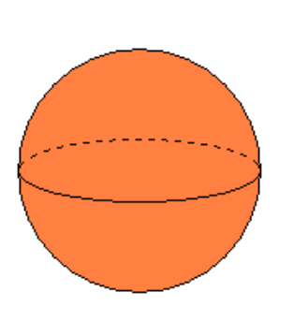  If the volume of the sphere is $36π {units}^{3}$, what is the radius of the sphere?  - 6 units  - 1 unit  =  - 3 units  - 12 units
7.  G.GMD.3 | At his trucking company, Fred received an order to ship 245 cubic feet of oil in cylindrical steel barrels. If each barrel has a radius of 1.3 feet and is 3.5 feet tall, how many steel barrels will Fred need?  - 12 barrels c. 14 barrels  - 13 barrels d. 15 barrels
8.  G.GMD.3 | What is the volume of the cylinder shown above if the diameter of the base is 8 inches and the height is 8 inches?  - $64 π cubic inches$ c. 256$π cubic inches$  - $128 π cubic inches$ d. $512 π cubic inches$
9.  G.GMD.2 | 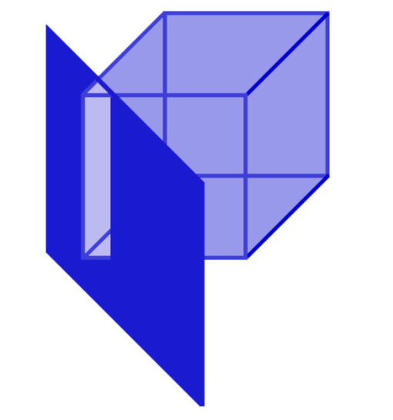  A cube is sliced diagonally, containing two vertices, and perpendicular to the base, as shown below. Which figure best represents the cross-section parallel to the slice?  - Rectangle  - Triangle  - Square  - Trapezoid  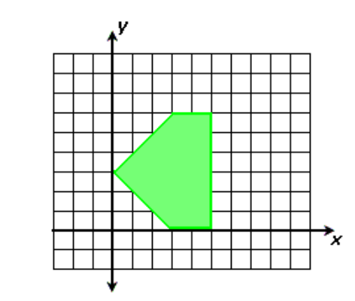
10.  G.GMD.2 | If the image to the right is rotated about the y-axis,  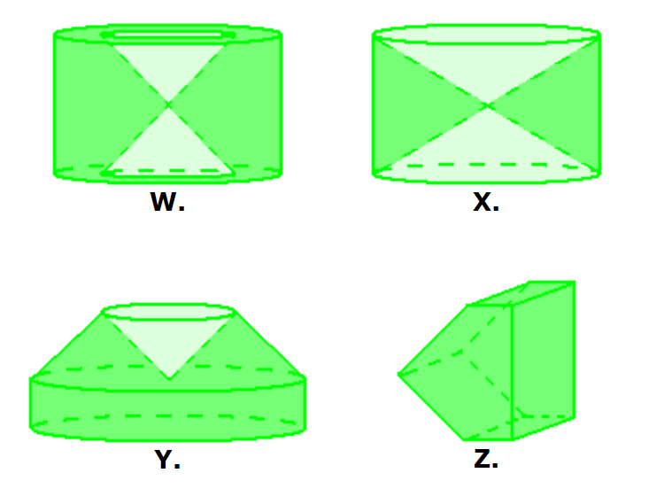  which of the following images best represents the result?  - Object W  - Object Y  - Object X  - Object Z
11.  G.GPE.4 | Which of the following equatios is perpendicular to the equation $y=\frac{2}{5}x+7$  - $y=\frac{2}{5}x-6$ c. $y=-\frac{2}{5}x-11$  - $y=\frac{5}{2}x+7$ d. $y=-\frac{5}{2}x+12$
12.  G.GPE.7 | The vertices of a rectangle are listed below with the following:  E(2,2) --- F(2,8) --- G(11,8) --- H(11,2)  What is the area of the rectangle?  - 216 square units c. 54 square units  - 108 square units d. 30 square units
13.  G.GPE.6 | Line segment RW has endpoints and . Point P is on such that is 2:3.  What are the coordinates of point P?  - (2, 9) c. (2, 14)  - (0,11) d. ( 10, 2)
Domain: Probability and Statistics 15%
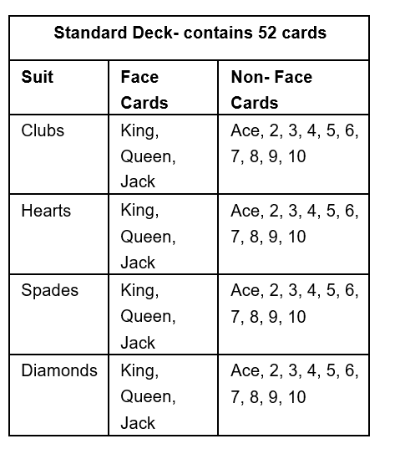
14.  S.CP.3 | A card is drawn from a standard deck of cards.  What is the probability that a card chosen is a 2,  Given that is a non-face card?  - $\frac{1}{13}$ c. $\frac{43}{52}$  - $\frac{4}{40}$ d. $\frac{1}{52}$
15.  S.CP.5 | 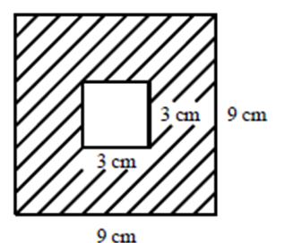  Find the probability of landing in the shaded region of the diagram below?  - $\frac{6}{18}$ c. $\frac{9}{81}$  - $\frac{3}{9}$ d. $\frac{72}{81}$
16.  S.CP.1 | 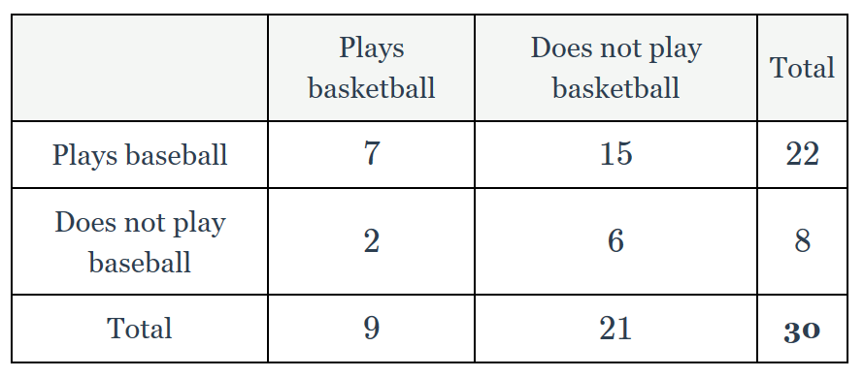  In a certain Algebra I class of 30 students, 9 of them play basketball and 22 of them play baseball. There are 6 students who play neither sport. What is the probability that a student chosen randomly from the class plays basketball or baseball?  - $\frac{4}{5}$ c. $\frac{1}{4}$  - $\frac{7}{9}$ d. $\frac{1}{30}$
17.  S.CP.1 | Using question #16. What is the probability that a student chosen randomly from the plays basketball and baseball?  - $\frac{1}{30}$ c. $\frac{7}{30}$  - $\frac{22}{30}$ d. $\frac{7}{22}$
18.  S.CP.5 | In a class of students, the following data table summarizes how many students play an instrument or a sport. What is the probability that a student plays a sport given that they play an instrument?  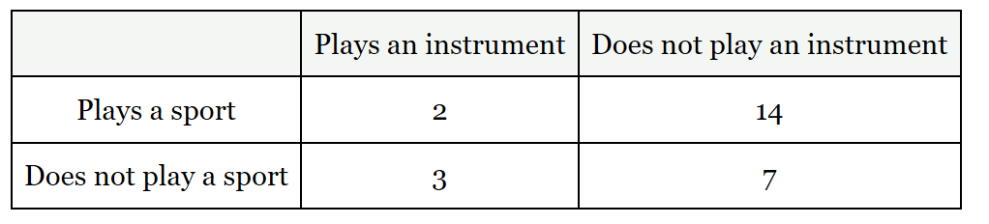  - $\frac{2}{14}$ c. $\frac{2}{30}$  - $\frac{2}{5}$ d. $\frac{3}{10}$
19.  S.CP.4 | A group of students at a high school took a standardized test. The number of students who passed or failed the exam is broken down by gender in the following table. Determine whether gender and passing the test are independent.  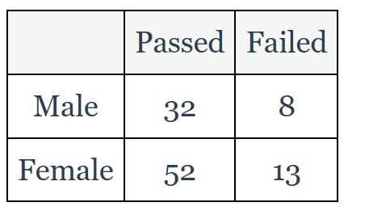  Since $P(female\left|pass)=\right.\frac{52}{84}$ and $P\left(female\right)= \frac{65}{105}$  - The two results are equal, therefore are dependent  - The two results are equal, therefore are independent  - The two results are unequal, therefore are dependent  - The two results are unequal, therefore are indpendent
20.  S.CP.1 | In a class of 25 students, 14 are female and 18 students have an A in the class. There are 11 students who are female and have an A in the class. What is the probability selecting a female student with an A in the classroom?  - $\frac{14}{25}$ c. $\frac{11}{14}$  - $\frac{18}{25}$ d. $\frac{11}{25}$

